Bassett Health Home
Bassetthealthhome@bassett.org


Netsmart User Guide
Table of Contents
Accessing Netsmart CareManager 4
Logging In 4
Password Reset 4
Locked Out of Your Account 4
Sign-Out/Lock Your Account 5
Home Page 5
Client List 6
Alerts 7
Tasks 7
Client Statuses in Care Manager 8
Demographics 9
Facesheet 13
Episode Detail 13
CMA Assignment 14
Gaps in Care 15
Programs 17
Health Plan Documentation 19
Care Manager Assignment 22
Consents 24
Data Sharing Consent DOH-5055 24
Data Sharing Types 27
Rescinding Consent 27
End-Dating Consent 28
Assessment Tab 29
Crisis/Safety Plan 29
HML Billing Questionnaire 31
Problems/Diagnosis 32
Creating the Interdisciplinary Care Team in CareManager 36
Social Support Contacts 36
Professional Network 39
Creating the Plan of Care 44
Initial Plan 44
Plan Of Care Finalization Workflow 51
Amendment 52
Plan Of Care Finalization Workflow Amendment 56
Annual 57
Plan Of Care Finalization Workflow Annual 61
Notes 63
Client Search Note 63
Outreach Note Example 66
Enrollment Note: Client Search Note 67
Contact Note 68
Billable Note 68
Non-billable Note 71
CareManager Note 71
Billable Note 71
Non-Billable Note 74
Hallmark Events 74
Adding a New Hallmark Event 75
Viewing and Editing Hallmark Event Information 76
ED Alert Documentation 77
Attachments 77
Attachments Overview 77
Navigating to Attachments 77
Member Discharge 82
Discharge Overview 82
Additional Forms 85
AHC HRSN SDOH Screening 85
Bassett Medicaid Check 86
Care Team Meeting 87
CES Tool 89
Communication Preferences 90
Continuity of Care Follow up Guide 92
Initial Appropriateness Tool 95
HCBS/CORE Services 96
Abbreviated Comprehensive Assessment 98
Comprehensive Assessment 100
Health Home Disenrollment Summary 101

Accessing Netsmart CareManager

Go to https://caremanager.netsmartcloud.com

Logging In
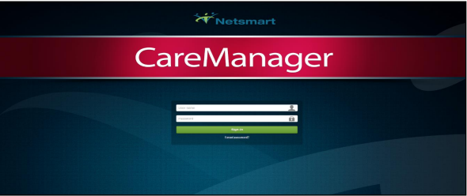

The Log-in Page is comprised of four elements:
User name- Your username is your email address
Password- The initial (temporary) password will be given out. The password must then be changed to:
Minimum of 8 characters
1 capital letter
1 number
1 symbol
Sign-in Button
Forgot Password link

Password Reset
If you need a password reset, please contact the Health Home email BassettHealthHome@bassett.org

Locked Out of Your Account
If you are logging in and you use the wrong password too many times the system will inform you that your account has been locked for 5 minutes. Please note that the password reset will not work until those 5 minutes are up. If you need to gain access before those 5 minutes are up you can contact BassettHealthHome@bassett.org

Sign-Out/Lock Your Account
In order to protect your clients PHI you have the ability to either lock or sign out of CareManager. In the upper right-hand corner of the screen you will see your name, clicking on it will give you the following options:
• Sign-Out-This will log you out of the system and take you to the sign in screen where you enter your username and password
• Lock-This will lock the application allowing you to put in your password and pick up where you left off in the system
• Refresh Permissions-This will refresh your security settings if they have been updated
• About CareManager -This will give you version information on CareManager

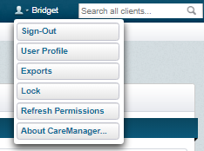

Home Page
Once you sign into CareManager, you will land on your Home page. 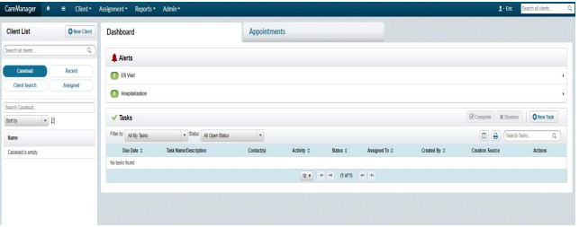

Client List

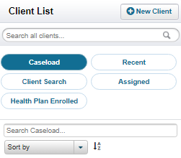

Client List is on the upper left side of the screen
• Caseload-When Caseload is selected, you will see every client that is in your caseload.
• Recent-When Recent is selected, it will show all of the client’s charts you have been in during your login session.
• Client Search-When Client Search is selected, it will show all of your client’s that are currently in Search status. Client Search is synonymous with Outreach.
• Assigned-When Assigned is selected, it will show all clients are in assigned status. Assigned indicates a new referral assigned to you. This is someone who has not been outreached yet. Once a search Note is finalized for a client in Assigned status, he or she will be moved to Client Search status.
• Health Plan Enrolled- When Health Plan Enrolled is selected, it will show all clients enrolled in a health plan in your agency.

Alerts

The alerts function will let you know if a client has gone to the hospital or emergency room if a HIE consent is signed (HIXNY). These alerts will automatically show in the system with consent and will create a Hallmark Event within the system.

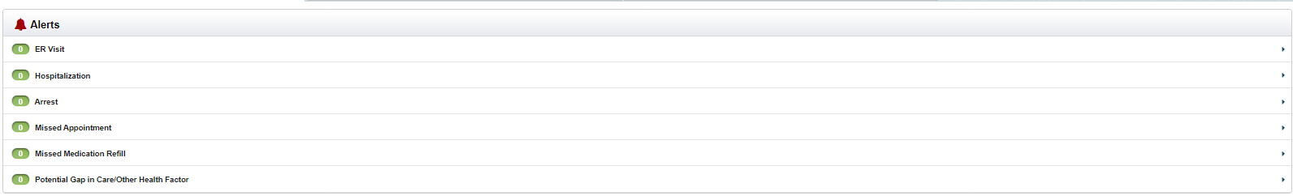

Tasks

Tasks are an optional feature and can be added as a reminder for you to track a task that needs to be completed. A task can be created from any tab in the member’ chart, or on the Dashboard. All tasks can be reviewed:
On your homepage
View tasks per client in the Facesheet tab of the client’s chart
By clicking on Tasks on the top of the screen when in a client’s charts.

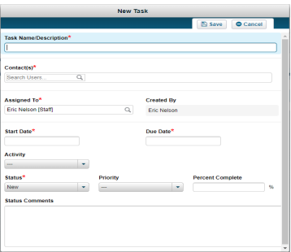

Creating a Task
1. Click on +New Task
2. Add Task Name/Description
3. Add any contacts or clients that are involved with the task
4. If you are assigning this task to another individual type their name in the Assigned To field
5. Set a Start Date and a Due Date
6. Select Activity category
7. Select Status and Priority
8. Click Save

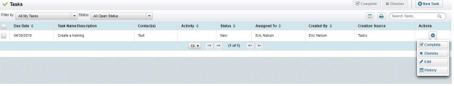

Ending a Task
1. Open the task you wish to end by selecting the “gear” icon associated with the task and select Edit
2. Change the Status to “Completed” or “Dismissed”
3. Click Save

Client Statuses in Care Manager

Assigned- If a member has a status of “Assigned” this means the client has not been outreached to and has not had a Client Search Note completed.

Client Search- The client status will change from Assigned to Client Search when a finalized Client Search Note is entered into the system with a status of Continue Search or Health Home Consent Pending. Any member in Outreach and Engagement will have a status of “Client Search” until they either enroll into the program or come to the end of their 2 months of outreach (at which point they would be automatically opted out of the program).

Opt-Out/Withdraw- Any member who is closed from an outreach and engagement segment will have a status of “Opt-out/Withdraw.” These members can still enroll in the program and may be eligible for an additional outreach effort.

Enrolled- When a client moves from an outreach segment to an enrollment segment, you’ll see their status change from “Client Search” to “Enrolled”. If a client is directly enrolled into the program, their status will say “Enrolled” when they are initially assigned to your agency.

Discharged- When an enrolled client is no longer continuing in Health Home Services, the client must be Discharged from CareManager. It is important that the client be discharged accurately in order to reflect correctly in MAPP.

Demographics
The Demographics feature houses the Personal, Contact, Health Home, and Demographic Survey information for a client. Information includes name, address, health home assignment, marital status, religious affiliation, etc.

Demographic Overview
The Demographics feature is comprised of four sections;
• Personal
• Health Home
• Contact
• Demographic Survey

Personal Information
The client’s Personal Information is entered in this section. Information such as the Last Name, First Name and Medicaid Identified Gender will pull forward from the Client Search screen.
In addition to the fields mentioned, the Personal information section also includes the following fields:
• Date of Birth
• Age
• Social Security Number (SSN)
• Identifier
• Alias History

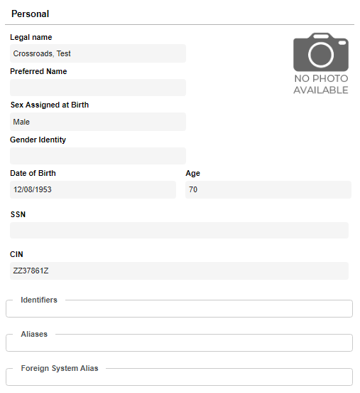
Contact Information
The Contact section includes all information needed to contact a client (not the client’s guardian, Case Manager, or similar). Information includes:
• Living Arrangements
• Email Addresses
• Addresses
• Phone Numbers
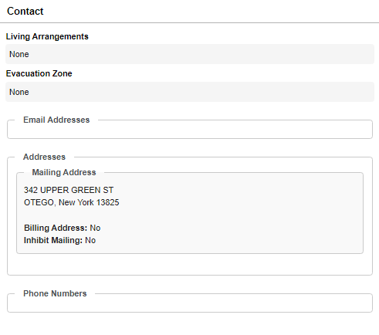

The Demographic Survey section contains more in-depth information about a client.
Information includes:
• Primary Language
• Communication Preference
• Smoking Status
• Marital Status
• Education
• Religion
• Ethnicity
• Hispanic Origin
• Tribe
• Race
• Country of Origin
• Country of Residence
• Citizenship
• Employment Status
• Occupation
• US Veteran
• Deceased
• Handicap
• Income Level

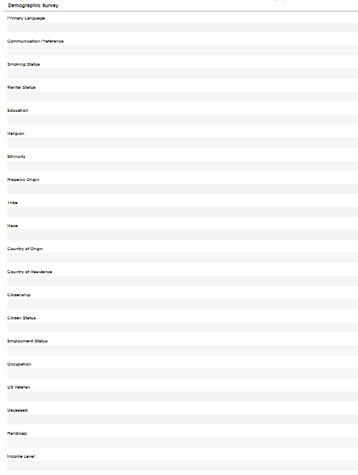
Navigating to Client Demographics
Demographics for a client already in the system can be accessed from the Home Screen.
1. From the Dashboard, select a client from the Client List

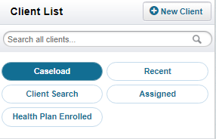

2. Select the Demographics tab from the left side of the screen.

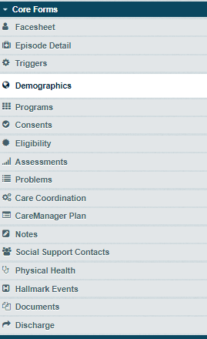

Editing Client Demographics
As information becomes available for a client, or information already gathered changes, the demographics information should be updated.
1. From the Demographics page, select the Edit from the top-right corner of the screen.

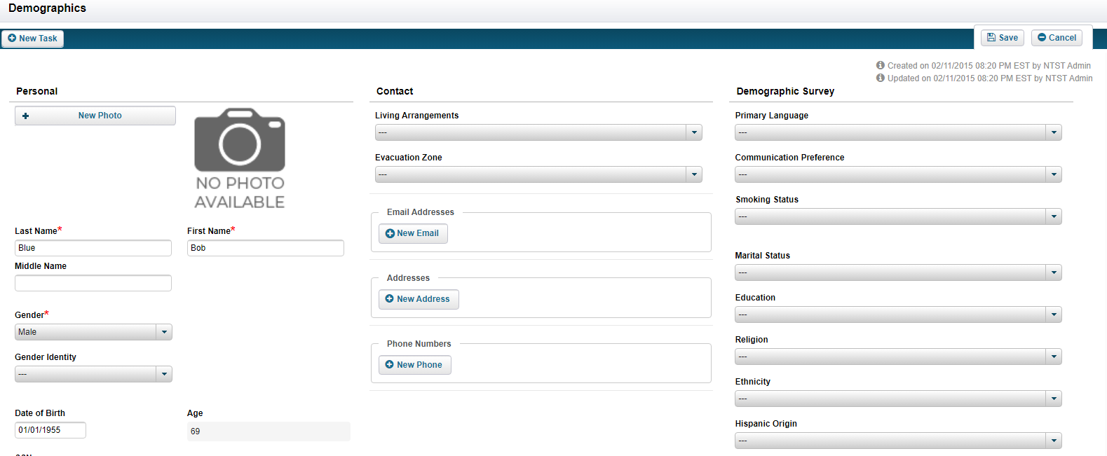

2. Once the demographics information has been updated, select the Save.

Facesheet

The Facesheet populates from information entered into the Demographics tab.
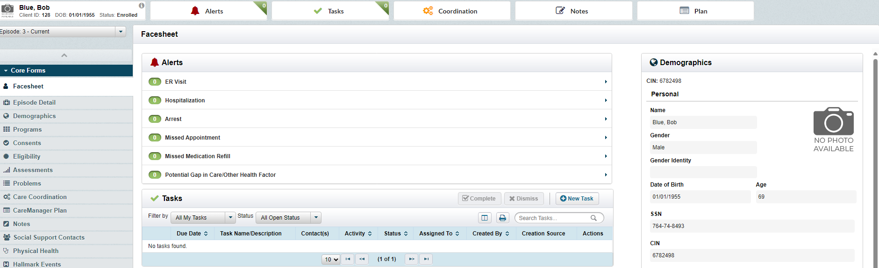

Episode Detail

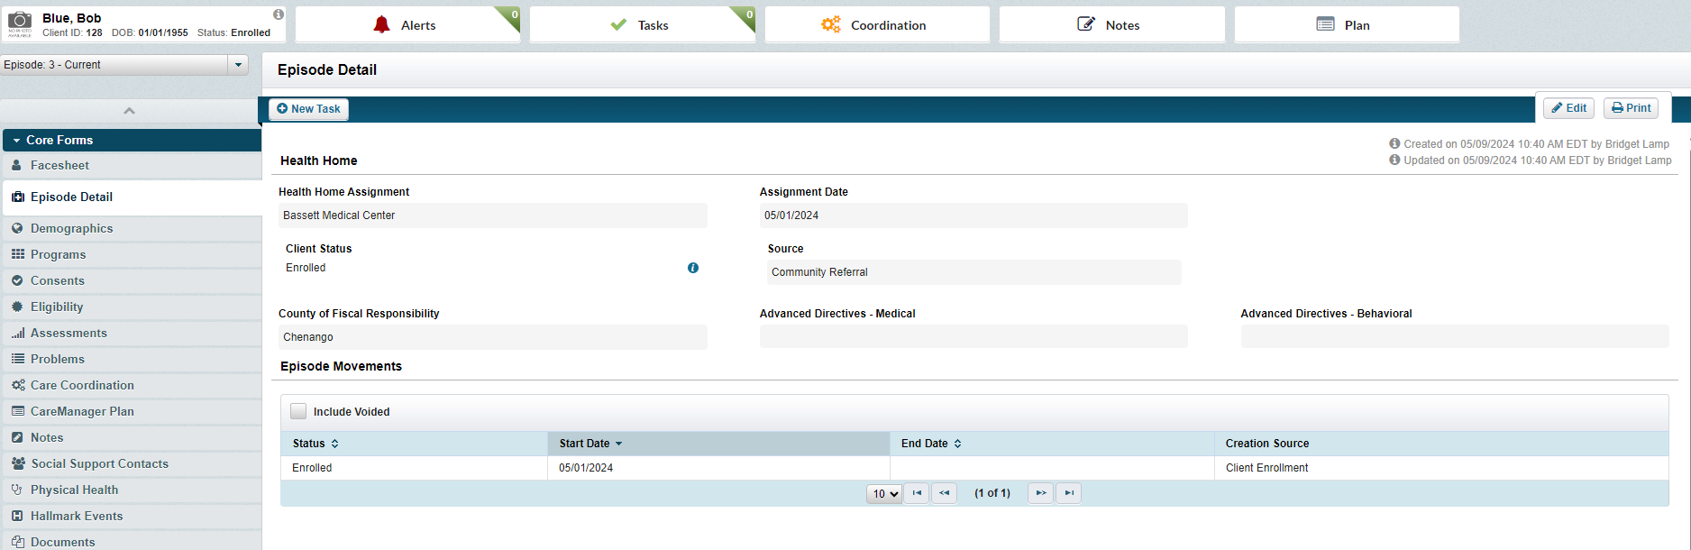

CMA Assignment
1. The Health Home Referral Coordinator will import members from MAPP, utilizing the MyMember Upload, to Netsmart each morning by 10 am.
- When members are assigned via the MyMember Upload, they will automatically be placed in Client Search status. Member will not appear in Assigned status.
2. CMA Supervisor will check Netsmart for assignments, daily. To do this, see below:
- Click on Assignments tab in the left-hand upper corner
- Click on Care Coordinating Agencies
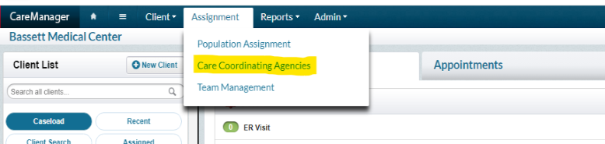
3. Select your agency (you may only see your agency)
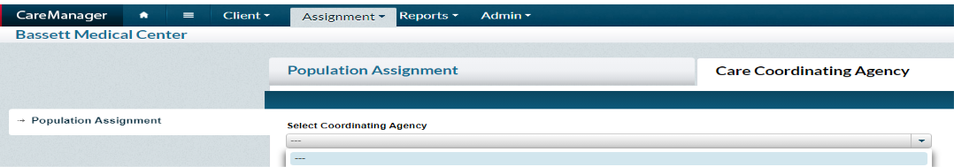
4. Members assigned to the CMA will appear in this section.
-Select Assign Care Team
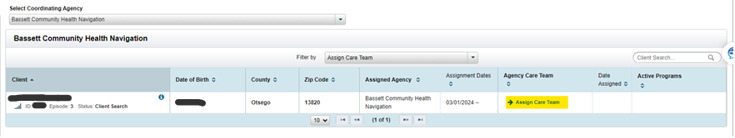
5. Select Add Team Member
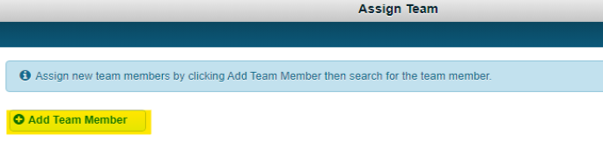
6. Type in Navigator’s / Care Manager’s name, and Select Primary Organization, Role, and assign date.
-Assign date must be the date that the member is being assigned to the Navigator / Care Manager
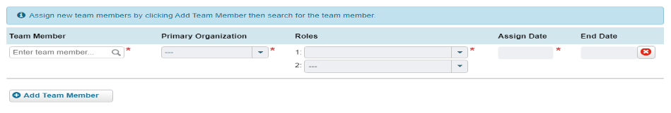7. CMA will then verify the information imported to Netsmart for accuracy:
-Episode detail has correct information
-Demographics match referral document
-Insurance info matches ePACES
-Care Coordination tab is accurate
8. Upload documents (See Attachment Section):
- Referral
- ePACES
- EPIC snapshot (reach out to HH Referral coordinator)

Gaps in Care
1.Each month MCO’s send a list of all GAPS in Care for members enrolled in the program. This is then uploaded into the system and will appear in the Gaps in Care Tab.
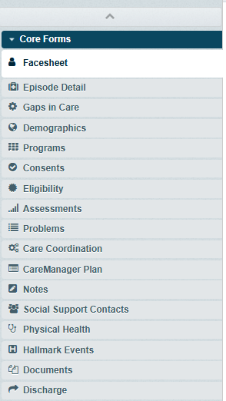

2.The Gap will show as new for each month that it remains open.

3.Click view

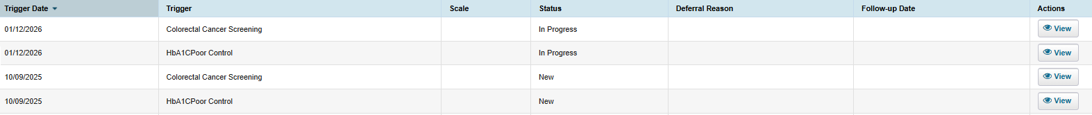

4.Once you are in the Gap in care simply click Edit; Adjust the status based on the progress made and create a comment. Save and close.
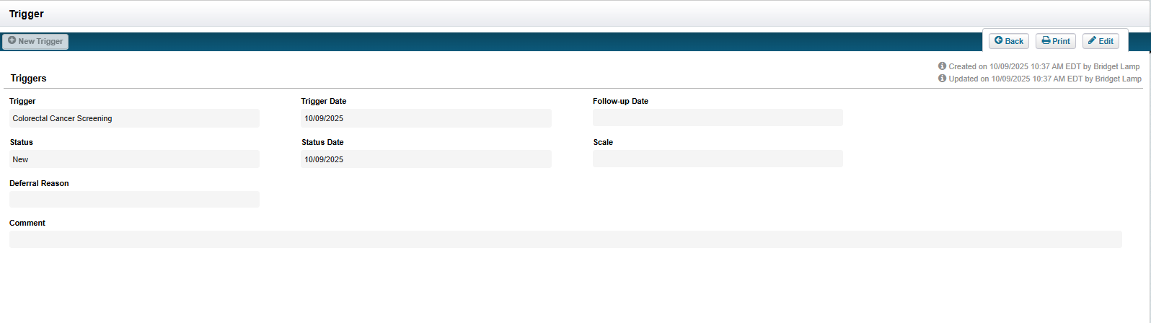

Programs

The Program page allows the user to associate a client to multiple Programs within an organization. Programs page will also display all Active Program(s) and Inactive Program(s). Programs will allow you to see different assessments and billing questionnaires depending on which ones you choose.

Program Overview
The Program page is comprised of three sections:
• Active Programs: The Program(s) the client is currently a member of.
• Inactive Programs: The Program(s) the client was previously a member of.
• Professional Network: Enrolled client’s in the HH Program.

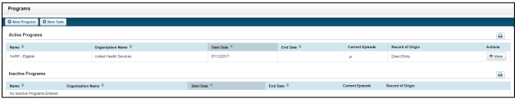

Navigating to Programs
Program information for a client already in CareManager can be accessed from the Home Screen.
1.From the Dashboard, select a client from the Client List.

2.Select the Programs tab from the left side of the page.

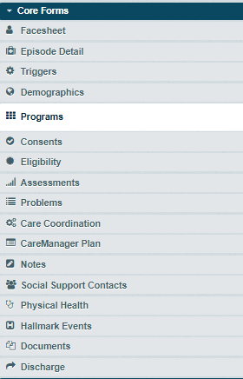

Adding New Program Information
New Program information can be added at any time from the Programs page.
1. Select the +New Program button.

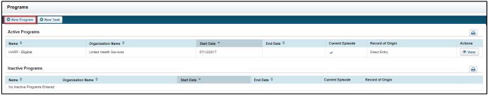
2. The Programs page will display. Select from the Program drop-down. Enter the Start Date for the program as well as the End Date if applicable.
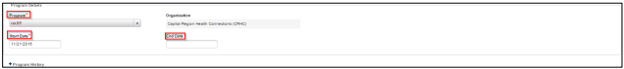

3. Select the Save or Save & Close button when once your selections have been made.

4. The green ‘Save Successful’ banner will show after you are brought back to the Programs page and you will now see the program under Active Programs.

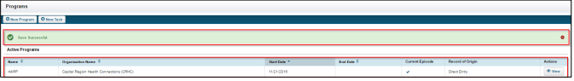

Editing Program Information
1. If a Program has been previously entered, select the View button to review the details.
2. You can select the Edit button to change the Start Date or End Date. You will also have a view of the Program History.

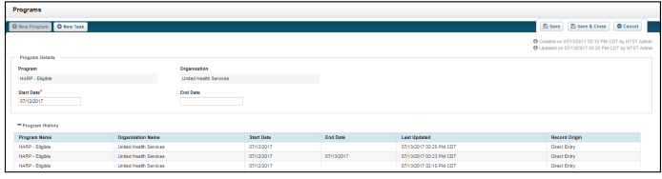

3. Select the Save or Save & Close button when finished.

Health Plan Documentation

Health Insurance (Medicaid) information can be entered and previously entered information modified. Medicaid information will be pulled down from MAPP initially, then it is up to your agency to maintain its accuracy. It is comprised of three sections:
• Active Health Plans
• Inactive Health Plans
• Health Plan History

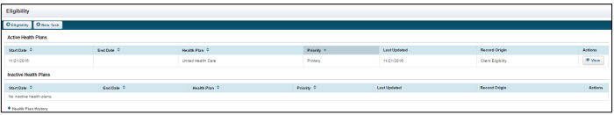

When entering or editing Health Plan information the page is partitioned into three sections per plan.
• Eligibility Information
• Health Plan Information
• Subscriber Information

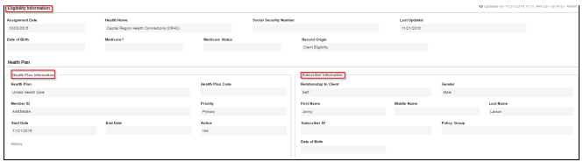

Adding New Eligibility Information
New Eligibility information/Health Plan information can be added at any time from the Eligibility page.

1. From the Home Screen, select a client from the Client List.

2. Select the Eligibility tab from the left-hand column.

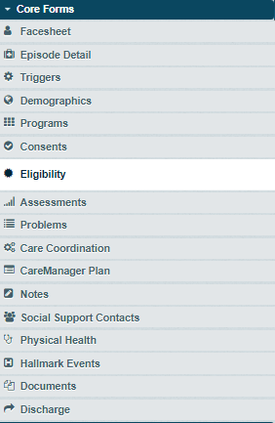

3. Select the +Eligibility button and then the +Health Plan button. This will bring you to the Eligibility screen.

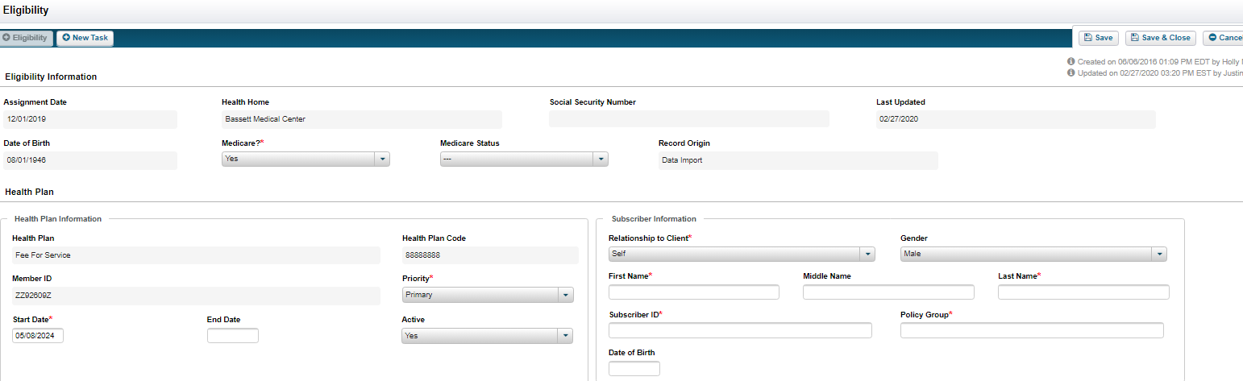

Documenting Eligibility
This is where a you will document eligibility information. The Assignment Date will auto-populate and cannot be modified.
1. The Health Home, Date of Birth, and Social Security Number fields will default to the information previously entered from the client’s Demographics.
2. From the drop-down enter the client’s Medicare? and Medicare Status if applicable.

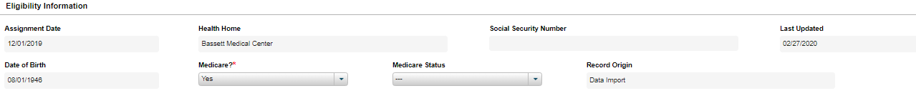

Medicaid needs to be set as the primary insurance.

The Last Updated and Record Origin fields will auto-populate upon saving.
Health Plan (New)
1. Select the Health Plan from the drop-down menu. The Health Plan Code will auto-populated based on the plan selected.
2. The Member ID will auto-populate based from the client’s previously entered information from the Demographics page.
3. Select the appropriate Priority from the drop-down menu. Note: Only one Health Plan can be identified as “Primary”.
4. Enter or select a Start Date.
5. Enter or select an End Date if applicable.
6. Choose if the plan is Active by selecting from the drop-down menu.

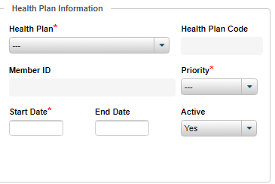

Subscriber Information
1. Select the subscriber’s relationship to the client from the Relationship to Client drop-down.
2. Select the appropriate Gender of the subscriber from the drop-down menu.
3. Type in the First Name, Middle Name, and Last Name of the subscriber in the open text field.
4. Enter in the subscriber ID in the Subscriber ID open text field.
5. Enter the subscriber’s policy group in the Subscriber ID open field.
6. Select or enter the subscriber’s date of birth in the Date of Birth field.

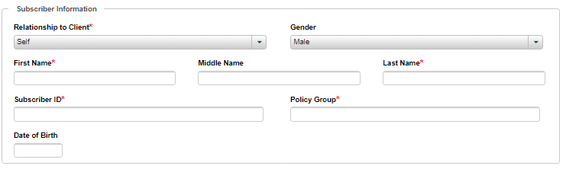

7. Once all the information has been entered, select the Save or Save & Close button.

Editing Eligibility Information Eligibility information can be viewed and modified quickly and easily from the Eligibility page. If eligibility has changed, an end date is required to add a new Eligibility.

1. If Eligibility information has been previously entered, select the View button.
2. Once viewing the Edibility Information page, select the Edit button.
3. The modifiable fields are now enabled. Once all the information has been updated, select the Save or Save & Close button.

Care Manager Assignment

1.Click on Care Coordination tab
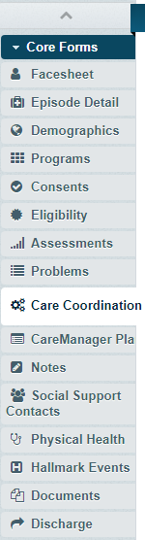

2.In the upper right had side you will click Assign New Agency

3.Click the appropriate Care Coordinating Agency and Assign Date then Save
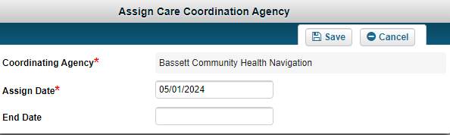

4.Click Assign Team
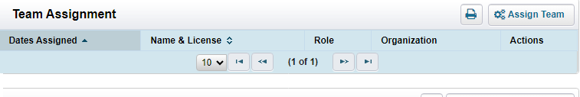
5.Team Member will need to be searched then complete Primary Organization, Roles and Assign Date fields. Save to complete.

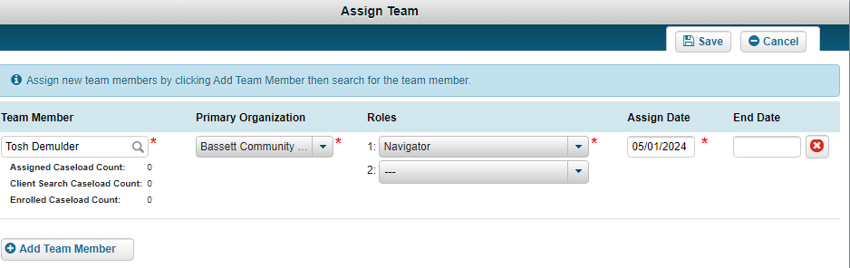

Consents

Data Sharing Consent DOH-5055
Consents

After the Health Home Consent to Enroll (DOH 5055) is signed and uploaded/added to CareManager there are other DOH consents that need to be obtained and uploaded.

1. From the Home View, select a client. The client Facesheet will display.
2. Select Consent Forms from the left side of the client chart. The Consent List will display. If there is previously entered consents, you will see them here.
3. Select the +New Consent button. A drop-down menu will appear allowing the user to select which consent form they want to complete, Health Home Consent or Data Sharing Consent.

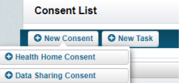

4. Select the +Data Sharing Consent button. This will open the client’s Data Sharing Consent form.

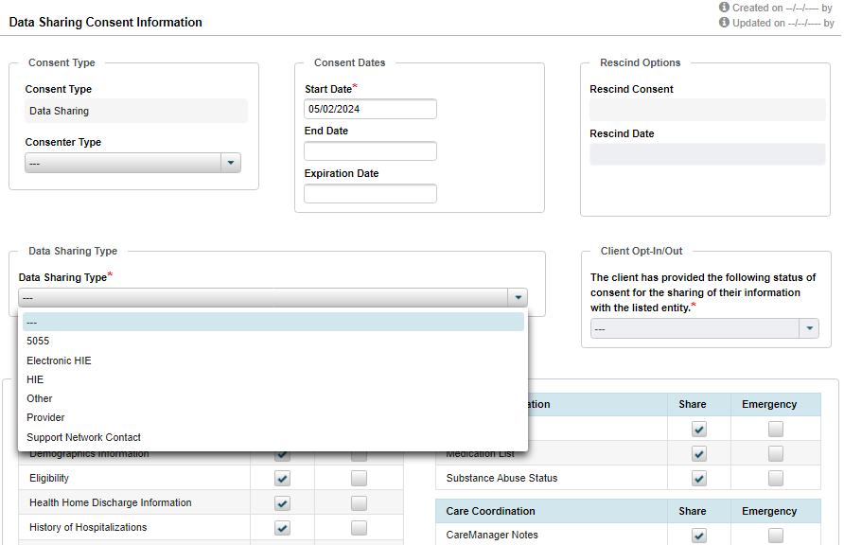

Complete the Data sharing Consent Information fields:
Start Date: Date the consent was signed.
End Date (if applicable): Date the consent was rescinded.
Expiration Date (if applicable): Use only if there is a time-limited consent.
Consenter Type: The name of the consenting individual.
Data Sharing Type: Please see below for the different data sharing types captured in this form. Client Opt-In/Out: Only use the “Opt-In” feature. This is when it has been confirmed consent has been obtained.

5. Fill out the appropriate Data Sharing Information the client would like shared. All Share checkboxes will be selected by default. If the client would only like their information shared in case of an Emergency, select that option. You can only have Share or Emergency selected for Client Care Information, Assessment Information, Documents, Sensitive Information and Care Coordination.

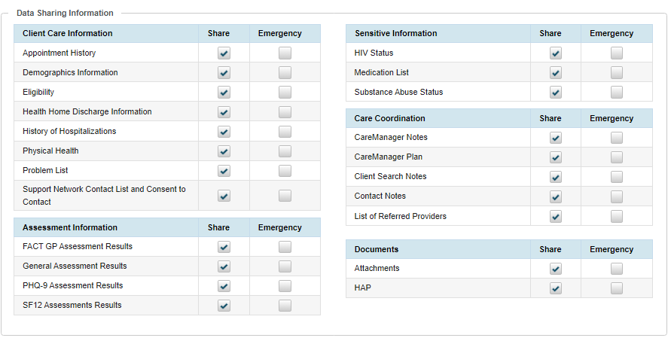

6. Write in your Comments at the bottom of the page. All comment history will show below the field if there have been previous comments for the client.

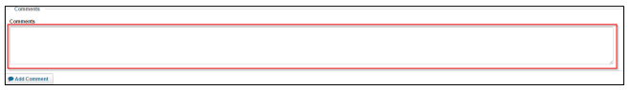

7. Select the Save or Save & Close button to finish the Data Sharing Consent. The green “Save Successful” banner will appear along with the consents.

Data Sharing Types

The Data Sharing Type are as follows:

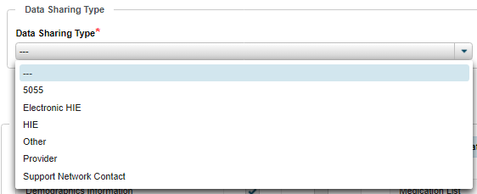

5055- Used to document the DOH 5055 when signed.

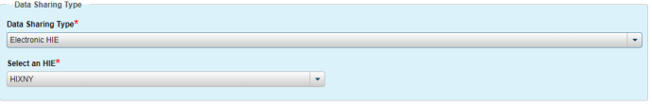

Electronic HIE- Select this type to document the receipt of a signed Health Information Exchange (HIXNY) consent
Provider- Select this type if you’re documenting a Provider that the client has given permission for you to share information with and is a member of the care team. Providers and Professional Networks will be gone over in greater detail later in the manual.
Support Network Contact- Use for any social supports be sure to list the level of consent the individual would like for this person. You can select the social support name from the list of Social Supports documented in that tab.
Other—Select this type if the consent you are documenting does not fit into any other category

Note: A scanned copy of all consents are required to be uploaded in the Attachments section of the chart.

Rescinding Consent

In the event a member/consenter no longer wants to share information with someone listed on the data sharing/minor data sharing consent the physical consent must be updated and re-scanned and uploaded into the member’s Attachments section of CareManager. Do not delete the previous version of the consent in the attachment’s areas.

In addition, if the person/entity removed from the consent was a member of the care team: you must also document this person/entity’s removal from the consent
1. Select View listed next to the party’s consent in the consent list
2. Select Edit
3. To rescind the consent, select the “Rescind?” check box. This will automatically input the end date to be the date “rescind” box is checked. If the person/entity was removed from the consent prior to you completing this step in the system, be sure to document this discrepancy in a contact note.
4. Do NOT switch the consent to Opt-Out in the Client Opt-in/out dropdown box. The system will automatically opt a client out of all consents when they are closed or discharged from the program.

If the person being removed from the consent was a member of the care team, be sure to end date their assignment on the care coordination page (in referred providers, professional network or social support contact section as applicable). Additionally, if the person was a social support, mark their contact status as “inactive.” Refer to the care team and social support sections for further details.

End-Dating Consent
End-Dating Consent
You may need to “end-date” a consent if there is a consenter change for a client or if they no longer want to consent to be in the Health Home program.

By ending consent, you must obtain new consents, including the consent to enroll, if they are to continue in the Health Home program. All previous steps to enter consent information must be followed and new consents must be scanned and uploaded into Attachments following the appropriate naming conventions. Previous versions of the consent should not be deleted from Attachments.

Contact Notes
Upon Enrollment all services will be documented in New Contact Notes until the client’s Initial Care Plan is finalized. Once the Initial Care Plan is finalized, all services and encounters can be documented as either New Contact Notes or New CareManager Notes, which will be gone over later in this manual.

Assessment Tab

Crisis/Safety Plan

- Select Assessments
- Select +New Assessment
- Select +Crisis Plan

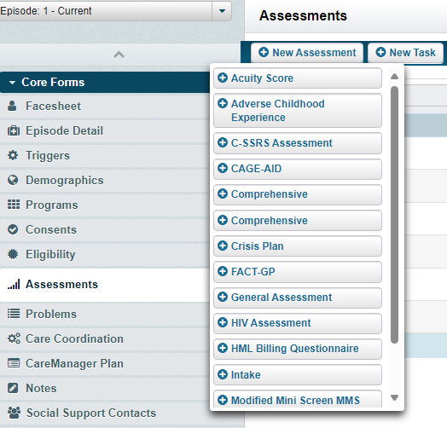

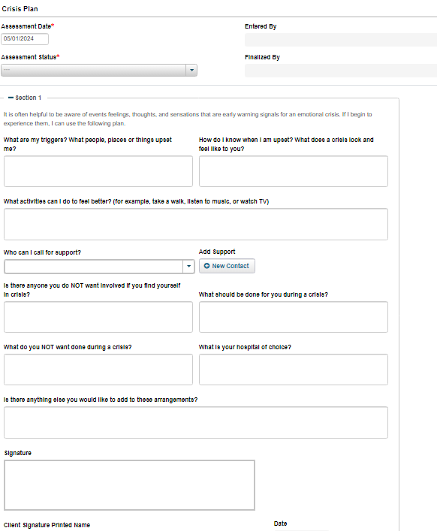

4. Complete all sections, be sure to Save.
5. Once all sections are complete with as much detail as possible finalize the Crisis Plan Save and Close.

HML Billing Questionnaire

HML (High, Medium, Low) Billing Questionnaire

Once a client is enrolled, a Billing Questionnaire must be completed monthly even if a billable service did not occur. For members with a billable service, the HML Billing Questionnaire serves as the attestation that a billable activity was completed. The HML Billing Questionnaire will be submitted to MAPP and/or to the payor for processing each month.

All questions will be prefilled from the previous month’s questionnaire with the ability to edit the answers. You must complete one assessment for each month the client is enrolled.
1. Select the Assessments tab
2. Select +HML Billing Questionnaire
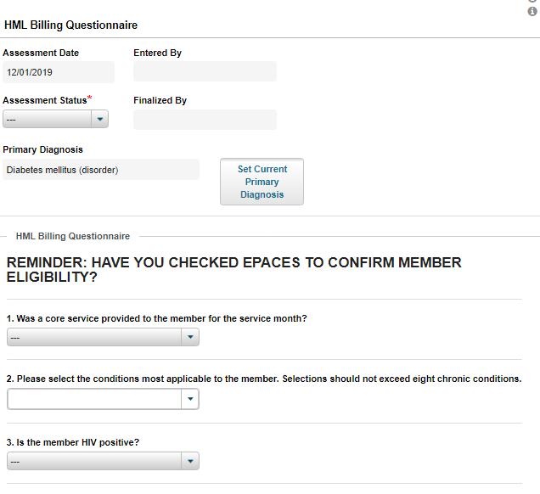

Assessment Date: This date will automatically default to the first day of the month, starting the first month a member is enrolled.
Entered By: The name of the person completing the HML.
Assessment Status: Draft or Final. Only finalize the HML when you know that all billable activities have been entered for the month.
Finalized By: This will prepopulate with the name of the person finalizing the HML.
Primary Diagnosis: This should match the identified primary problem in the system. To verify the diagnosis is correct, click Set Current Primary Diagnosis. Remember that the Primary Diagnosis identified must be a qualifying condition for enrollment in the Health Home program.
1) Was a core service provided to the member for the service month? Yes or No answer. If you answer yes you will be asked for the date of core service.
2) Please select the condition most applicable to the member. Identify the qualifying chronic conditions that determined the member’s eligibility for the Health Home. This should match the primary diagnosis.
3) Is the member HIV positive? Yes or No answer

Questions 4-14: If there is a Yes answer to these questions, additional questions will populate to capture the most information about the member. After all questions are answered, you will need to attest that all of the responses are accurate.

Problems/Diagnosis

The Problems feature houses the Problem Type, Chronicity, Onset, Severity, and Status of the client’s problems. Capturing the member’s problems are crucial to many of CareManager’s features such as documenting a Care Plan and Referring to Providers. The Primary Problem is the diagnosis that qualifies the client for care management services. If they have two chronic health conditions you will select one as primary, and one as secondary.

If any additional Problems need to be created, or edited/deleted please follow the below workflow:

Navigating to Problems

1. From the Home Page¸ select a client from the Client List.
2. Select Problems from the navigation list on the left.

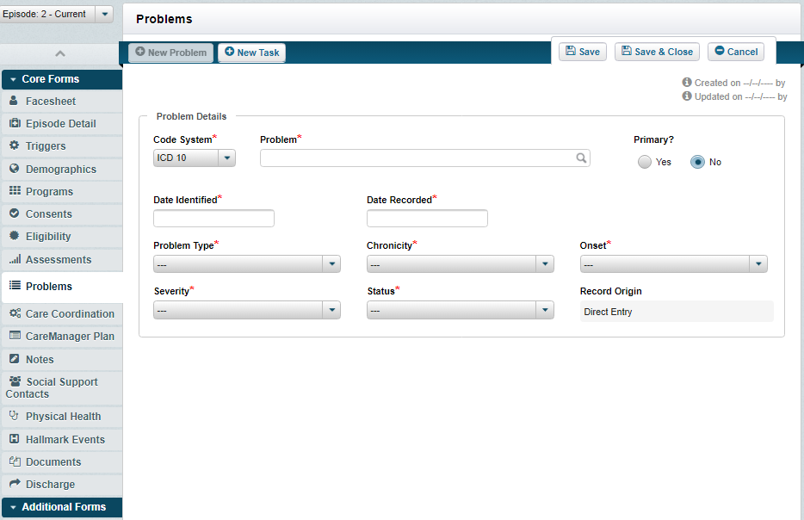

Adding a New Problem
1.Select the +New Problem button. The Problems Details screen will appear.

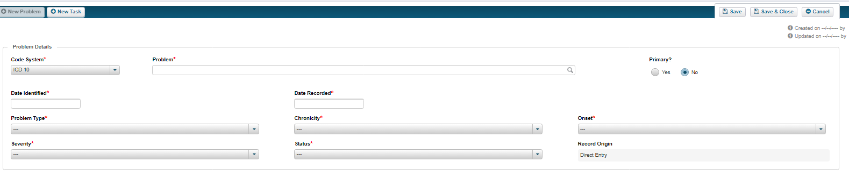

Code System: The problems Code System consist of SNOMED, DSM IV, DSM 5 and ICD 10 searches. The SNOMED, DSM IV and DSM 5 may require a user to select the ICD 10 code associated with the description or code chosen, if setup to do so.
Problem: The problem free text field will search for the problems entered based on the Code System selected.
Date Identified: This is the date a member was diagnosed with the problem. If this is unknown, use the date of the document that details out the diagnosis.
Date Recorded: This is the date the problem was added to CareManager.
Problem Type: This is the category the problem is associated with. This feature’s functionality is tied to the Care Plan.

The Care Plan’s functionality tied to the Problem Type is listed below. The Care Plan section dives into more detail.
• Adherence (Non-Problem Type Specific)
• Behavioral Health (Problem Type Specific)
• Physical Health (Problem Type Specific)
• Social Health (Problem Type Specific)
• Care Coordination Activities (Non-Problem Specific)

Chronicity: The Chronicity drop-down will have you select the frequency of the problem.
Onset: The Onset drop-down will have you select the time in the member’s life that the problem started.
Severity: The Severity drop-down will have you select the harshness of the problem.
Status: The Status of the problem will allow you to select Active and Non-Active status’s associated with the problem. This feature has functionality tied to the Care Plan. Active problems will be able to be pulled to a Care Plan and Non-Active problems will not be able to be pulled into the members Care Plan.
• Active
• Inactive
• Member chooses to not address
• Monitoring
• Resolved
• Unresolved

2. Select the Code System you would like to search.
3. Search for a problem in the Problem field by description.
4. The descriptions will appear below the search. Select the appropriate description.
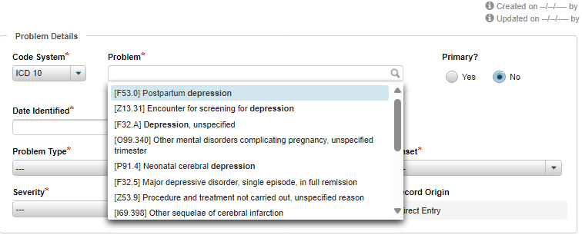
Note: The first ‘Problem’ entered for a client will default as their Primary problem. Once more than one problem has been entered for a client, you can choose to change which ‘Problem’ should be Primary.

5. Enter the Date Identified and the Date Recorded
6. Select the Problem Type from the drop-down.
7. Select the Chronicity from the drop-down.
8. Select the Onset from the drop-down.
9. Select the Severity from the drop-down.
10. Select the Status from the drop-down.
11. The Record Origin will auto-populate with Direct Entry when a user enters the problem.
12. Select the Save or Save and Close button to save the entered problem information.
13. The green ‘Save Successful’ banner will present once you are brought back to the Problems page. You will also be able to view the added problem at that time.

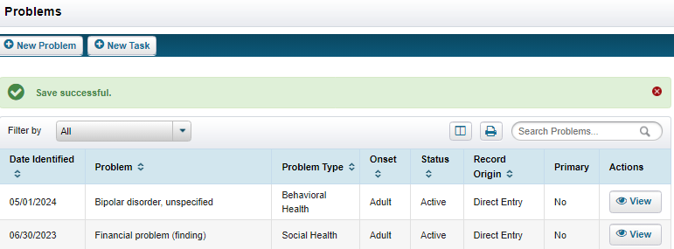

Editing Problems

Problems can be viewed and modified within the problem feature. Depending in your permissions, options are available to Delete the problem, change the ICD Code associated with the problem and the Problem Details.

1. From the Problems page, select the View button for the Problem that needs to be modified.

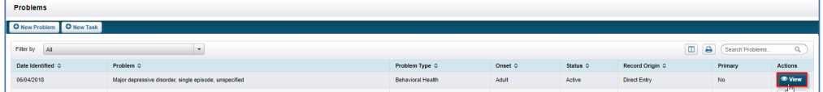

2. Select the Edit button. The editable fields will become enabled.

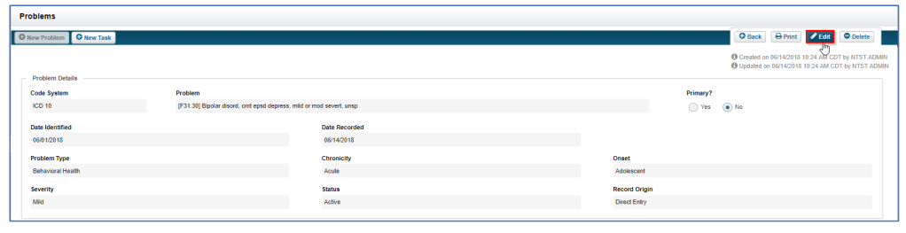

3. The previously entered information will display. This includes the Problem, Diagnosis Information and Linked Referrals.

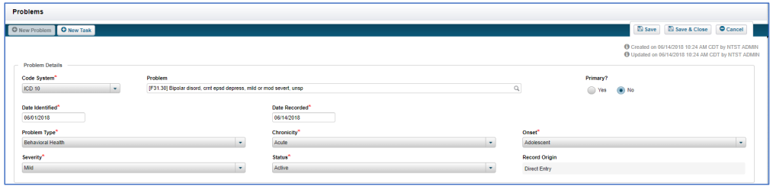

4. Once the Problem has been updated, select the Save or Save and Close button.

Deleting a Problem
1. Select the View button next to the problem you would like to delete.
2. In the upper right-hand corner select the Delete button.
3. A confirmation window will display. Select the Yes button.

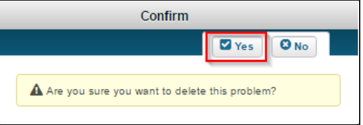
Note: A problem cannot be deleted if it has already been added to a Care Plan.

Creating the Interdisciplinary Care Team in CareManager

The Care Team can consist of internal resources at your agency, external providers that the client/family reported during the assessments and social support contacts who play an active role in the member’s care. Every care team member must be listed on the Care Coordination page of the client’s chart.

Social Support Contacts

A client’s Social Support Network can be a key factor in helping them stay engaged with their care. A Social Support Contact(s) can be defined as a client’s mother, father, step-parent, sister, brotherrelative, spouse, sponsor, etc. Once the Social Support Contacts have been added into CareManager, those supports can be assigned as part of the client’s Care Team, if appropriate. Social Support Contacts may also have a Data Sharing Consent on record if the client has provided permission for the Social Support Contact to have access to their care information.

Adding Social Support Contacts
1.From the Home View, select a client from the Client List.

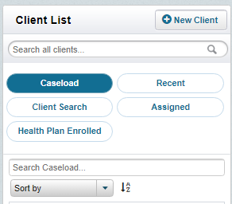

2.Select Social Support Contacts tab from the left side of the page.

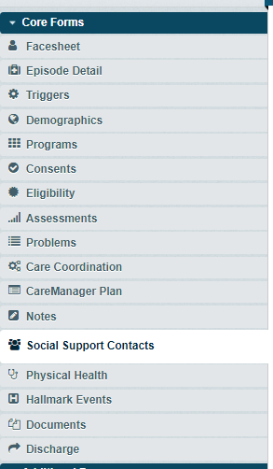

3. From the Social Support Contacts tab, you will be able to see if any social supports have been added or not.
4. To add a new support contact select the +New Contact button from the top left corner of the page.
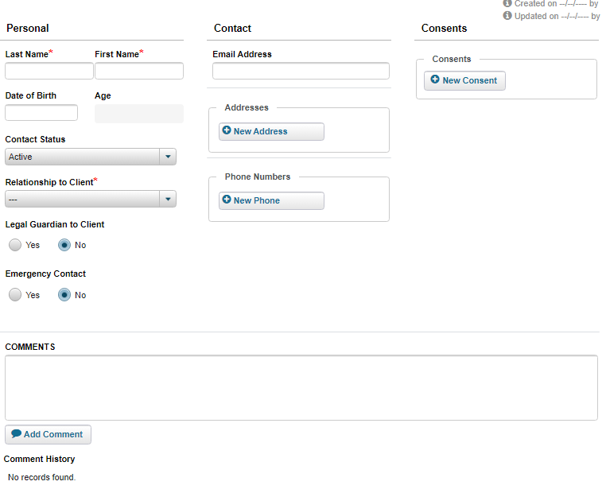

5. Once selected, the Personal, Contact, and Comments section becomes editable.
6. Fill in the Last Name, First Name, Contact Status, Relationship to Client, and if the support is a Legal Guardian and if the support is an Emergency Contact.
7. Enter the Email Address, Addresses, and Phone Numbers, if applicable.
8. To enter an Address, select the +New Address button. You can add as many addresses as you would like by continuing to select the New Address button.
Note: You can select the red ‘X’ in the top right corner to remove the address if needed.
9. To add a Phone Number, select the +New Phone button. Select the Type from the drop-down menu and enter the Number in the open field. Select the checkboxes for Confidential and Primary if applicable.
10. If Consent has been given to the Support Contact, select the +New Consent button. The Data Sharing Consent modal will display.
11. Enter the Consent Dates. The date will auto-populate with today’s date.
12. From the Client Opt-in/Out drop-down, select Client Opt-in.
13. Make sure all applicable Data Sharing Information is checked correctly.
14. Enter any comments in the Comments section of the consent.
15. Select the Save button once all information is entered.
16. The green banner stating ‘Save Successful’ will show on the Social Support Contacts page.
17. Enter any Comments that are needed at the bottom of the Social Support Contacts page. You will also be able to see a history of any comments added to the social support.
18. Select the Save or Save & Close button to finish adding the Social Support Contact

Assigning a Social Support Contact

Once a Social Support Contact has been added to CareManager, the Support Contact needs to be assigned to the client’s Care Team, if appropriate.
1. From the Home Page, select the client from the Client List.
2. Select the Care Coordination tab from the left of the screen. The Care Coordination screen will display as shown below.

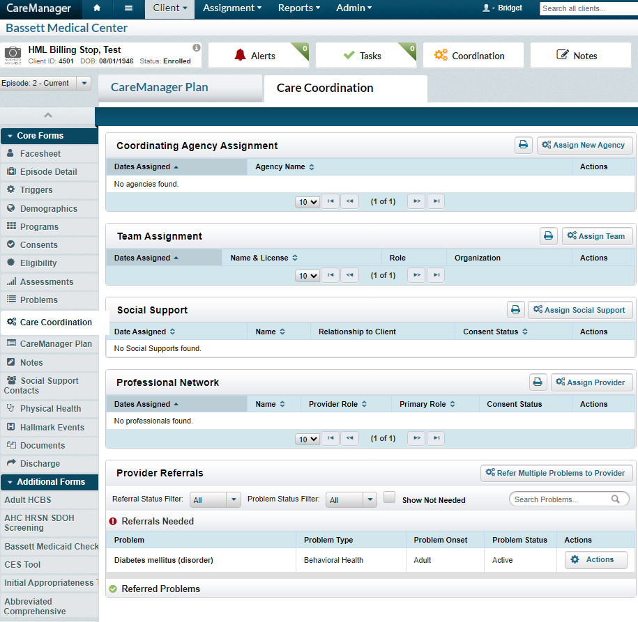

- If there has not been a previously entered Social Support assigned in Care Coordination, a note stating ‘No Social Supports found’ will display.
- Select the Assign Social Support button. The Assign Social Support modal will display.

Professional Network

When needing to access information about a Provider in CareManager, the user has an option to select a previously entered Provider from a Search List. If the Provider cannot be found, the Add Custom Provider feature allows the user to enter a new provider. The steps provided below shows adding a Custom Provider when referring problems on the Care Coordination page, but this same process is used in the Medications and Hallmark Event features as well.
Navigating to the Chart using the Client List
On the HOME sCREEN, select a client from the Client List by placing your mouse over the Client’s Name, or the Client’s Photo, or the Chart icon under their name.
- When you click on the client’s information CareManager will display the client’s chart.
Note: The Client Chart can also be accessed by selecting the Client Menu, selecting the desired section of the Client Chart, and searching for the Client.

Adding a Custom Provider
- Select Care Coordination from the left hand menu of the client chart.
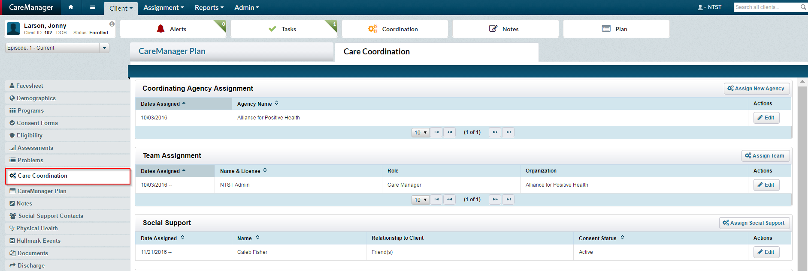
- The Care Coordination page will display.
- Select the Refer Multiple Problems to Provider button located next to the problem that needs to be referred. This is located within the Provider Referrals section.
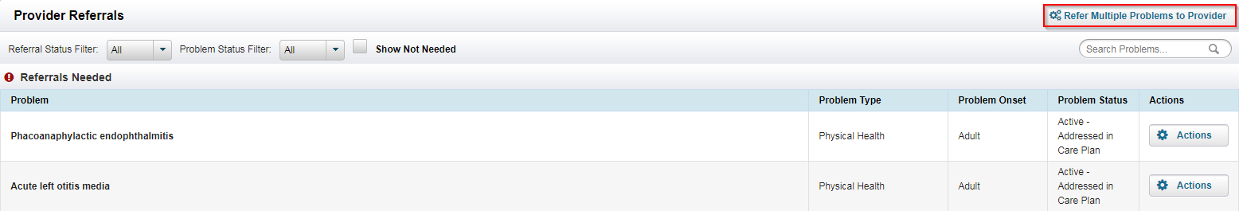
- The Refer to Provider pop-up modal will display.
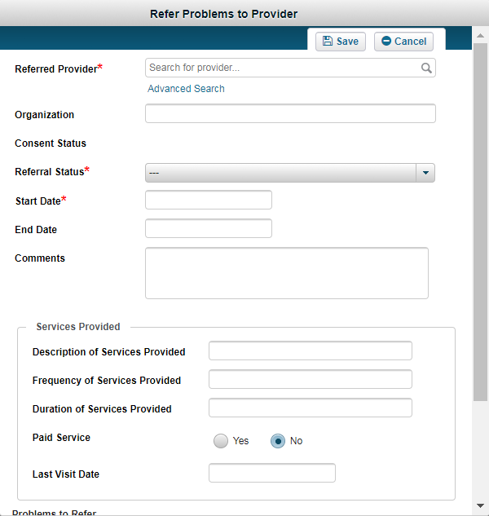
- Enter the provider name in the Referred Provider field. The entered name will display with [Add Custom] following. Select the name that the user has entered.
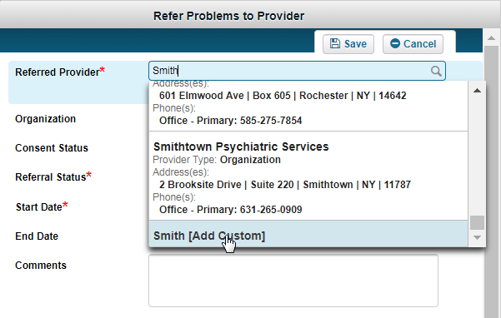
- The Advanced Provider Search pop-up windown will display, as shown below.
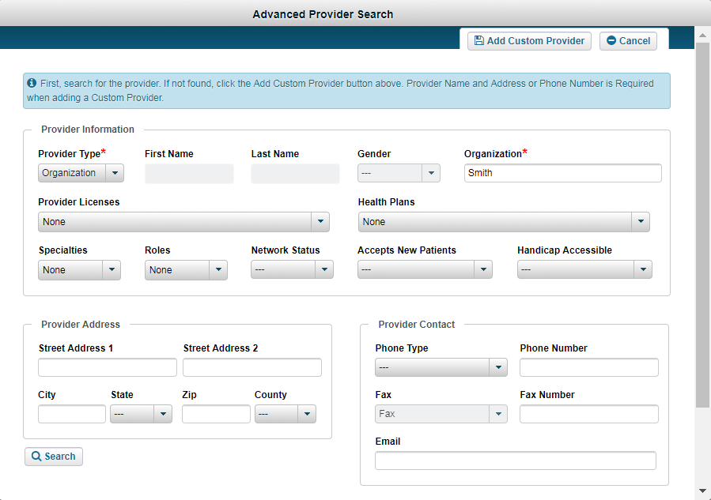
- Complete the Provider Information, Provider Address and Provider Contact fields. Select Individual from the Provider Type drop-down to add an individual. To add an organization, use the default Provider Type of Organization.
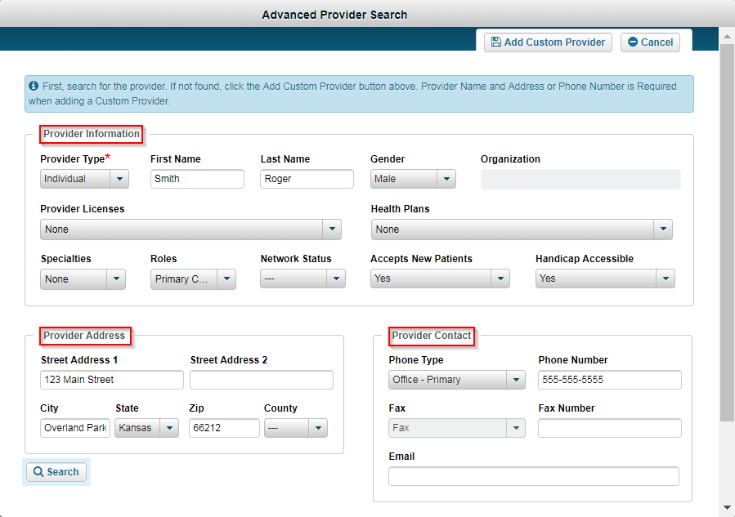
- Select the Search button once you have entered your desired information.
- The search results will present at the bottom of the screen. If a provider exists with the information you had entered they will show at the bottom of the screen. If they do not exists and need to be created, you will see the following:
- Select the provider if applicable. If there are no providers in the search results, select the Add Custom Provider button.
- The Confirm Provider Add pop-up screen will display.
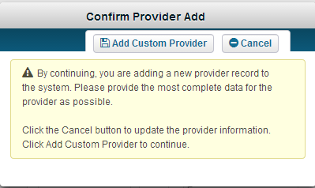
- Select the Add Custom Provider button.
- The Refer to Provider modal will display again.
- Enter the Organization if applicable.
- Select the if applicable.
- Select the provider referral status from the Provider Referral Status drop-down menu.
- Enter in the Referral Start Date.
- If applicable, enter the Referral End Date.
- Enter any Comments you would like to add to the referral.
- If applicable, enter information in the Services Provided section of the referral. Available options are Description of Services, Frequency of Services Provided, Duration of Services Provided, Paid Service, Last Visit Date.
- Select the Problem(s) to Refer.
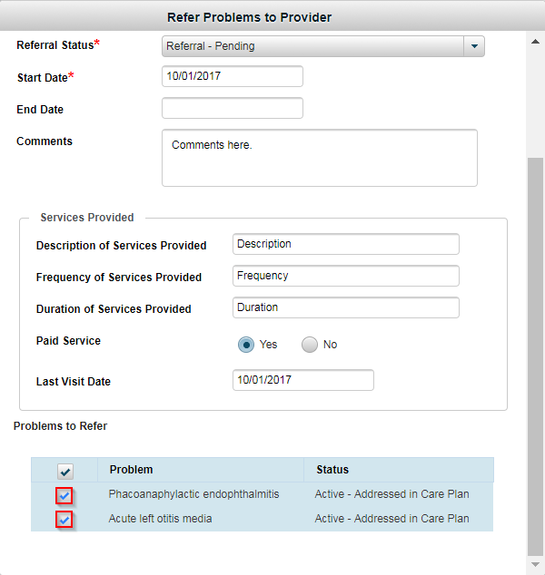
- Select the button. The information entered will save and the user will be returned to the Care Coordination page.
- In the Provider Referrals section of the Care Coordination page, hover over and select the caption icon. The icon is located next to the Referred To field.
- The Provider Demographics information will display.
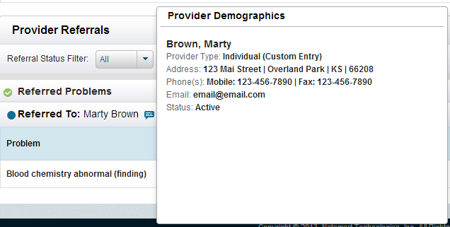

Creating the Plan of Care

Initial Plan
- The Initial Plan is the first CareManager Plan created for a client.
- The Plan Amendment provides the flexibility to a Care Manager or Care Coordinator to make changes to the finalized plan when needed. As client care progresses, the plan may need to be updated quickly and easily.

Entering an Initial CareManager Plan

On the Homescreen, select a client from the Client List.
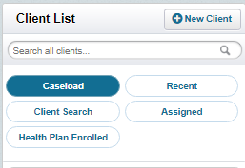

- Select the CareManager Plan tab from the left side of the screen.
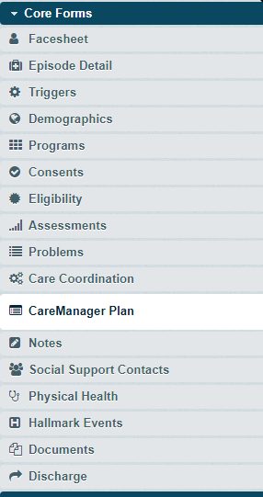
- If no CareManager Plans have been created, a note stating “No Plans Entered” will display.
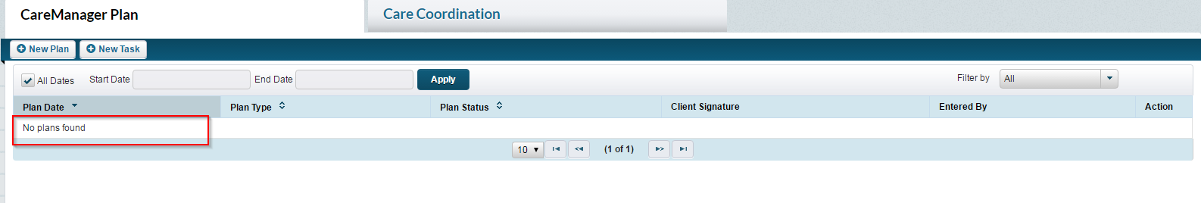
- To add a new plan, select the button.

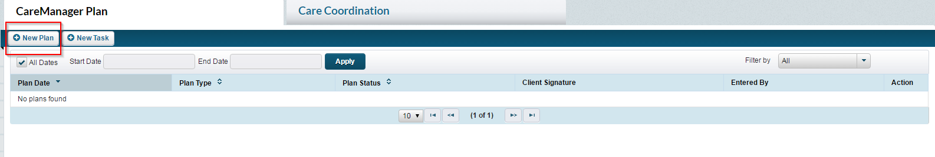

- The following screen will display:
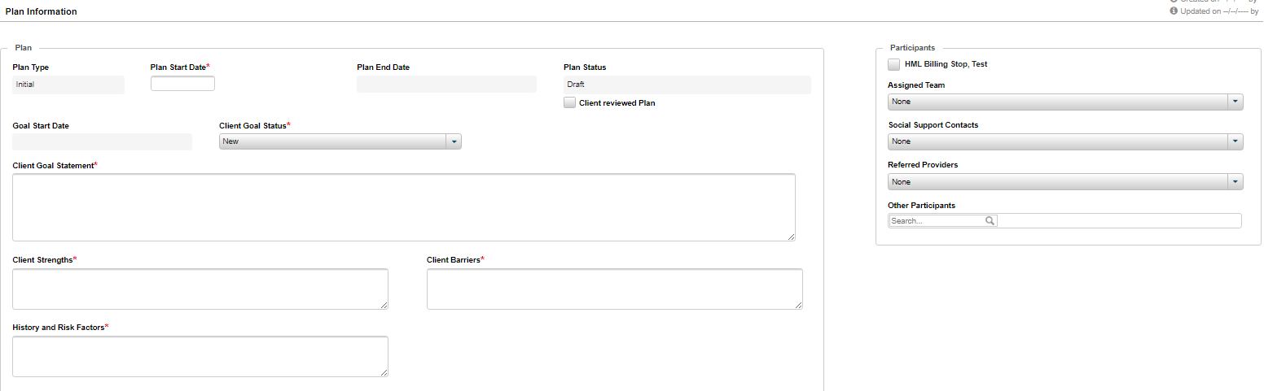
- In the Plan section, the Plan Type will default to Initial.
- Enter a date in the Plan Start Date field.
- The Plan End Date field will be greyed out.
- While working on the CareManager Plan, the plan should remain in Draft status. This field will be revisited at the end of the exercise.
- The Goal Start Date field will be greyed out.
- Enter an overall goal in the Client Goal Statement field.
- Enter information in the Client Strengths field.
- Enter information in the Client Barriers field.
- Enter information in the History and Risk field.
- Objectives/interventions can be custom creations or selected from the libraries created. The following default categories are available For Objectives and Interventions:
- Adherence
- Behavioral Health
- Physical Health
- Social Health
- Care Coordination Activities
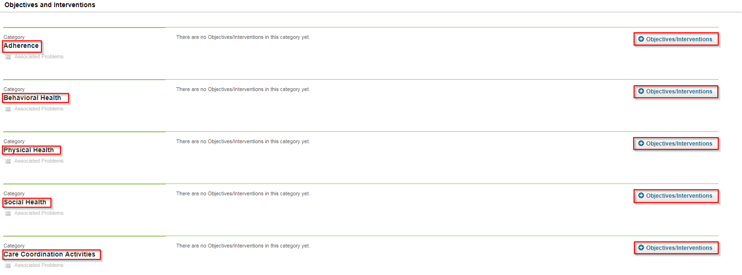
- In the Objectives and Interventions section, find the appropriate category for the objective/intervention and select the 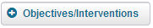 button.
- Select the button.
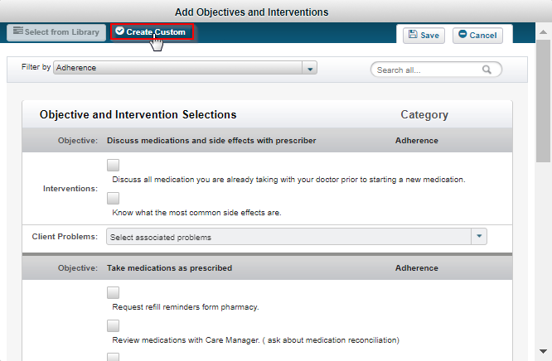
- Type in an objective in the Objective field.
- Select the appropriate category from the Category drop-down menu.
- Enter intervention(s) in the Intervention field(s). If there are more than four interventions, select the button.
- Select the appropriate problem(s) from the Associated Client Problems drop-down menu.
- Continue adding Objectives, a Category and Interventions as needed.
- Select the button. The entered items will now be listed in the CareManager Plan.
- The Status of each new Objective will default to New.
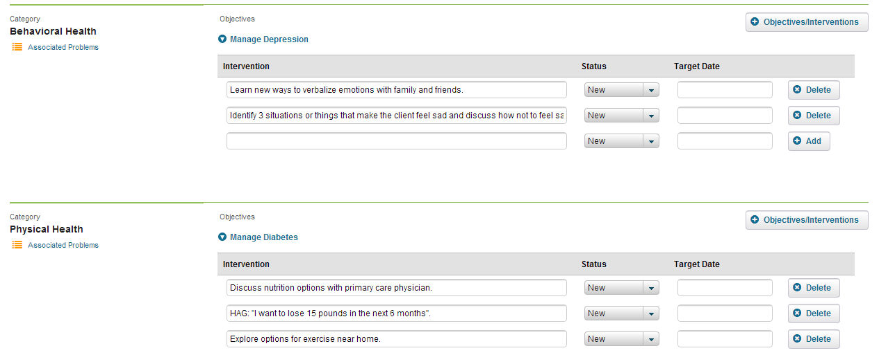

- Enter a date in the Target Date field.
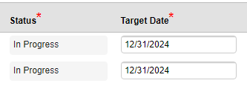
Adding Participants to a CareManager Plan
Scroll to the top of the CareManager Plan to the Participants section.
Select the check box next to the client’s name.
- Select the participants from the Assigned Team drop-down menu.
Note: There must be a primary CareManager assigned in order to finalize the Care Plan.
- Select the participants from the Social Support Contacts drop-down menu if applicable.
- Select the participants from the Referred Providers drop-down menu if applicable.
- If there were other participants involved in the creation of the CareManager Plan, enter a name in the Other Participants field.
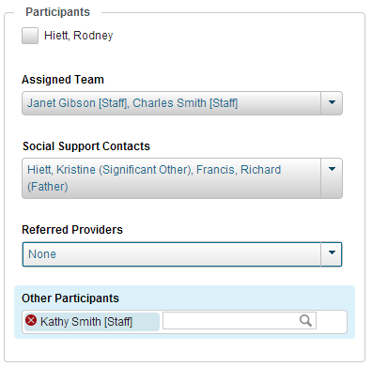

Editing a Draft CareManager Plan
CareManager Plans in a status of Draft can be viewed and modified if needed.
- From the Dashboard, select a client from the Client List.

- Once in the Client Chart, select the CareManager Plan feature in the tabs on the left.
Note: The CareManager Plan can also be found by selecting the Client menu in the CareManager toolbar on the Homepage and then Plan from the list of features in the menu.

- The previously entered plan will display.
- Select the button to retrieve the CareManager Plan.
- To make any modifications, select the button. All fields that are modifiable will become enabled.
- Make the necessary changes and select the or button.
Finalizing and Signing the CareManager Plan
- Once the CareManager Plan has been completed and reviewed with the client, select the checkbox next to Client reviewed Plan. The Plan Status will change from Draft to Final and the Plan End Date field will become active.
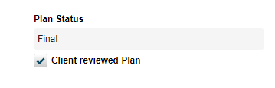
- Enter a date in the Plan End Date field based on policy.
- Once the plan has been moved to Final Status, the Signature fields become enabled for both the Client and Care Manager.
- You have the option to use the Mouse, or Manual signature types.
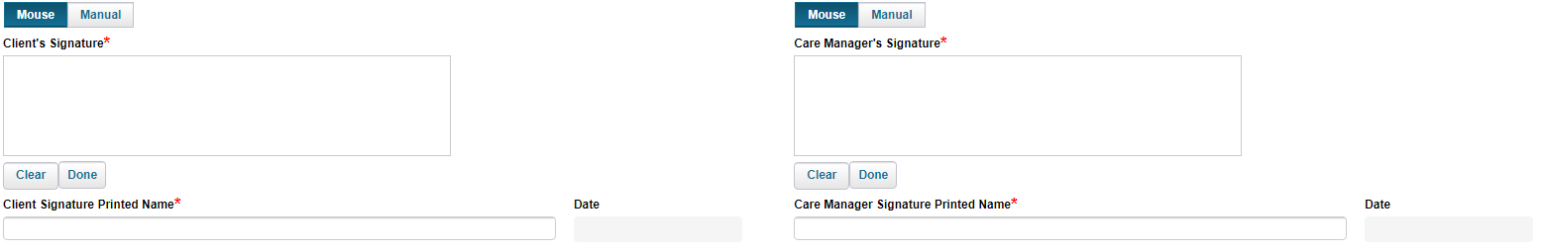
- Type in the client’s name and the care manager’s name in the Printed Name free text field below each respective area.
- If Mouse is selected, use your mouse to write the signature by holding down the left mouse button to draw the signature.
- Using the Manual option will allow you to Save the plan without a signature. You will need to print the plan off and manually sign. Select the Manual button to active this option.
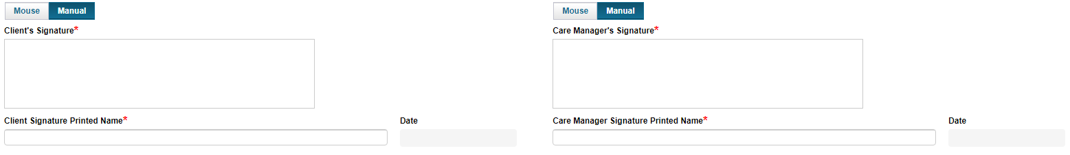
- Once you are finished with the signature portion of the plan, select the Save or Save & Close button to save the finalized plan.

Plan Of Care Finalization Workflow
The member’s approval of the plan of care is shown by the retrieval of the member’s signature.

1. Electronic signature is the preferred method of approval.

2. Manual signature can be obtained if there are no means for obtaining an electronic signature. But requires:
- Initials on each page.
- Signature and Date on last page.
- Upload to the POC in NetSmart within 3 business days and finalized.

3. Until a manually signed plan is attached and contains each of these components it is considered incomplete and will not be reported to the MAPP system.

Outlined below are the steps to appropriately upload a Manually obtained signature.

- The care manager meets with member and obtains the manual signature on the POC. Once the signature is obtained the plan is then finalized and a new attachment button will become available.

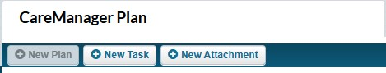

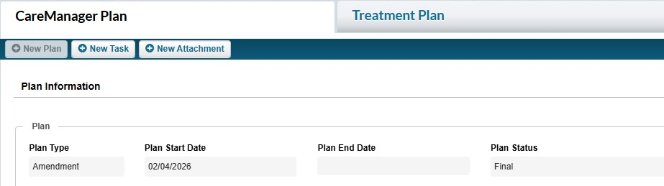

- Once The New Attachment button is selected a dialog box will appear. This is the same as the dialog box from the Attachments page with a few changes.

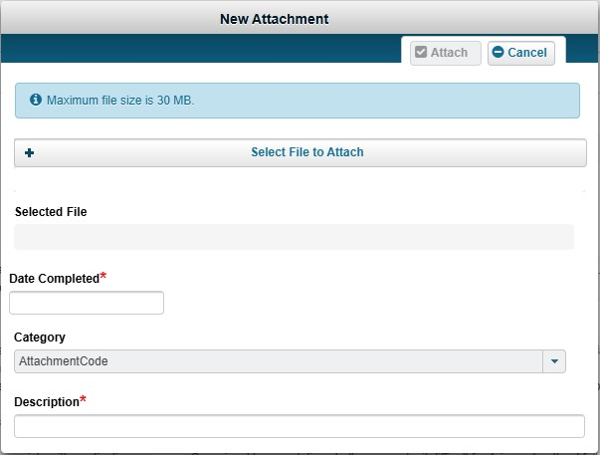

Date Completed is defined as the date of member signature. This field will be limited to dates between the plan start date and today.

Category will automatically default to member signed plan of care.

- Once the document is attached there will be a timestamp to show when that action occurred. The attachment will then be available to download from the Care Plan and or the Attachments section of the chart.

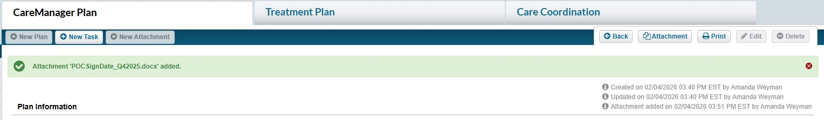

Amendment

A CareManager Plan Amendment can easily be created once a client’s Initial Plan has been finalized and saved. The information from the previous plan will pull forward into the new plan. As client care progresses, the plan may need to be updated quickly and easily.
1.From the Dashboard, select a client from the Client List.
2.Once in the client chart, select the CareManager Plan feature from the tab on the left.
Note: The CareManager Plan can also be found by selecting the Client menu in the CareManager toolbar on the dashboard and then Plan from the list of features in the menu.

- Any previously entered plan(s) will display.
- To add a new plan, select the +New Plan button.
- Select the +New Plan Amendment 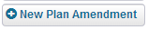 button.
- In the Plan section, the Plan Type will default to Update.
- The current date will default in the Plan Start Date field. Change the date if needed.
- The Plan End Date field will be greyed out.
- The Plan Status field will auto populate with Draft.
- The Goal Start Date will populate with date of the previous care plan entered.
- Select a status from the Client Goal Status drop-down menu.
- The Client Goal Statement, Client Strengths and Client Barriers will be populated with the information from the Initial Plan.
- Review the previously entered goal in the Client Goal Statement field and modify if needed.
- Review the previously entered information in the Client Strengths field and modify if needed.
- Review the previously entered information in the Client Barriers field and modify if needed.
- The previously entered Objectives and Intervention will display. The status of each previously entered intervention(s) is In Progress.
- Modify the date in the Target Date field if needed.
- Any new interventions can be added at this time below the previously entered interventions. Select the +Add button if more need to be entered than is available.
- Scroll to the top of the CareManager Plan to the Participants section.
- Select the check box next to the client.
- Select and/or modify the participants from the Assigned Team drop-down menu.
Note: There must be a primary CareManager assigned in order to finalize the Care Plan.

- Select and/or modify the participants from the Social Support Contacts drop-down menu if applicable.
- Select and/or modify the participants from the Referred Providers drop-down menu if applicable.
Select and/or modify the participants in the Other Participants field.
- Once the CareManager Plan Amendment is complete and reviewed with the client, select the checkbox next to the Client reviewed Plan field. The Plan status will change to Final and the Plan End Date field becomes active.
- Once the CareManager Plan has been completed and reviewed with the client, select the checkbox next to Client reviewed Plan. The Plan Status will change from Draft to Final and the Plan End Date field will become active.
- Enter a date in the Plan End Date field based on policy.
- Once the plan has been moved to Final Status, the Signature fields become enabled for both the Client and Care Manager.
- You have the option to use the Mouse, or Manual signature types.
- Type in the client’s name and the care manager’s name in the Printed Name free text field below each respective area.
- If Mouse is selected, use your mouse to write the signature by holding down the left mouse button to draw the signature.
- Using the Manual option will allow you to Save the plan without a signature. You will need to print the plan off and manually sign. Select the Manual button to active this option.
- Once you are finished with the signature portion of the plan, select the Save or Save & Close button to save the finalized plan.

Plan Of Care Finalization Workflow Amendment
The member’s approval of the plan of care is shown by the retrieval of the member’s signature.

1. Electronic signature is the preferred method of approval.

2. Manual signature can be obtained if there are no means for obtaining an electronic signature. But requires:
- Initials on each page.
- Signature and Date on last page.
- Upload to the POC in NetSmart within 3 business days and finalized.

3. Until a manually signed plan is attached and contains each of these components it is considered incomplete and will not be reported to the MAPP system.

Outlined below are the steps to appropriately upload a Manually obtained signature.

4.The care manager meets with member and obtains the manual signature on the POC. Once the signature is obtained the plan is then finalized and a new attachment button will become available.

- Once The New Attachment button is selected a dialog box will appear. This is the same as the dialog box from the Attachments page with a few changes.

Date Completed is defined as the date of member signature. This field will be limited to dates between the plan start date and today.

Category will automatically default to member signed plan of care.

5.Once the document is attached there will be a timestamp to show when that action occurred. The attachment will then be available to download from the Care Plan and or the Attachments section of the chart.

Annual

When it is time for an Annual CareManager Plan, an Annual plan can be created. Like the Plan Amendment, the Annual plan will pull into the plan any active (New or In Progress) Objectives & Interventions from the most recent CareManager Plan. All Objectives & Interventions that were completed prior to the creation of the Annual Update Plan will not display in the new plan as active CareManager Plan items being worked on by the client.

1.On the Dashboard, select a client from the Client List.
2.Once in the client’s chart, select the CareManager Plan feature in the tabs on the left.
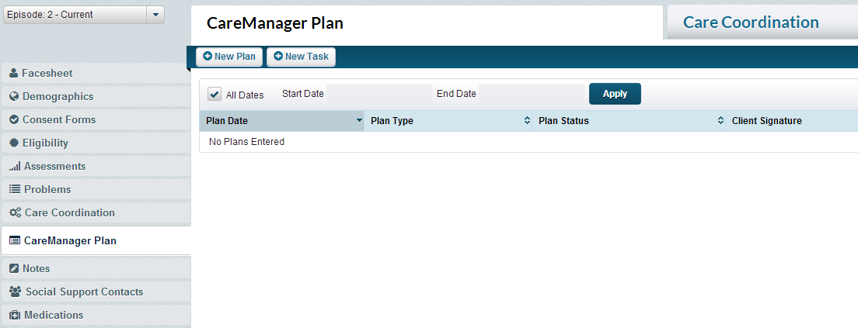
Note: The CareManager Plan can also be found by selecting the Client menu in the CareManager toolbar on the dashboard and then Plan from the list of features in the menu.

3.Any previously entered plan(s) will display.
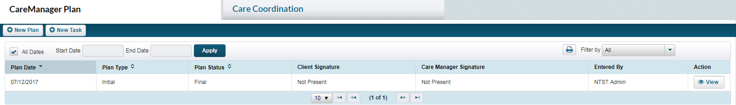
4.To add a new plan, select the +New Plan button.
5.Select the +ANNUAL Plan button.
6.In the Plan section, the Plan Type will default to Annual.
7.The current date will default in the Plan Start Date field. Change the date if needed.
8.The Plan End Date field will be greyed out.
9.The Plan Status field will auto-populate with draft and be greyed out.
10.The Goal Start Date field will be greyed out.
11.Select the client goal status from the Goal Status drop-down menu.
12.Review the previously entered goal in the Client Goal Statement field and modify if needed.
13.Review the previously entered information in the Client Strengths field and modify if needed.
14.Review the previously entered information in the Client Barriers field and modify if needed.
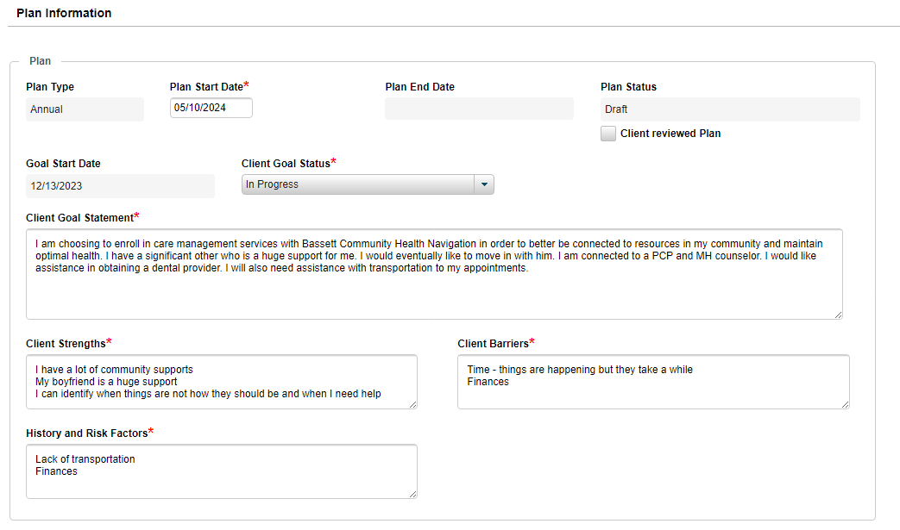
15.The previously entered Objectives and Intervention will display. The status of each previously entered intervention(s) is In Progress.
16.Modify the date in the Target Date field if needed.
17.Any new interventions can be added at this time below the previously entered interventions. Select the +Add button if more need to be entered than is available.
18.Scroll to the top of the CareManager Plan to the Participants section.
19.Select the check box next to the client.
20.Select and/or modify the participants from the Assigned Team drop-down menu.
21.Select and/or modify the participants from the Social Support Contacts drop-down menu if applicable.
22.Select and/or modify the participants from the Referred Providers drop-down menu if applicable.
23.Select and/or modify the participants in the Other Participants field.
24.Once the CareManager Plan has been completed and reviewed with the client, select the checkbox next to the Client reviewed Plan field. The Plan status will change to Final and the Plan End Date field becomes active. No more changes can be made to the plan, and when viewing the plan the Edit button will be disabled.
25.Enter a date in the Plan End Date field based on policy.
26.Once the CareManager Plan has been completed and reviewed with the client, select the checkbox next to Client reviewed Plan. The Plan Status will change from Draft to Final and the Plan End Date field will become active.
27.Enter a date in the Plan End Date field based on policy.
28.Once the plan has been moved to Final Status, the Signature fields become enabled for both the Client and Care Manager.
29.You have the option to use the Mouse, or Manual signature types.
30.Type in the client’s name and the care manager’s name in the Printed Name free text field below each respective area.
31.If Mouse is selected, use your mouse to write the signature by holding down the left mouse button to draw the signature.
32.Using the Manual option will allow you to Save the plan without a signature. You will need to print the plan off and manually sign. Select the Manual button to active this option.

33.Once you are finished with the signature portion of the plan, select the Save or Save & Close button to save the finalized plan.

Plan Of Care Finalization Workflow Annual
The member’s approval of the plan of care is shown by the retrieval of the member’s signature.

1. Electronic signature is the preferred method of approval.

2. Manual signature can be obtained if there are no means for obtaining an electronic signature. But requires:
- Initials on each page.
- Signature and Date on last page.
- Upload to the POC in NetSmart within 3 business days and finalized.

3. Until a manually signed plan is attached and contains each of these components it is considered incomplete and will not be reported to the MAPP system.

Outlined below are the steps to appropriately upload a Manually obtained signature.

4.The care manager meets with member and obtains the manual signature on the POC. Once the signature is obtained the plan is then finalized and a new attachment button will become available.

- Once The New Attachment button is selected a dialog box will appear. This is the same as the dialog box from the Attachments page with a few changes.

Date Completed is defined as the date of member signature. This field will be limited to dates between the plan start date and today.

Category will automatically default to member signed plan of care.

5.Once the document is attached there will be a timestamp to show when that action occurred. The attachment will then be available to download from the Care Plan and or the Attachments section of the chart.

Notes

Client Search Note

Once a client is processed and accepted through MAPP, the client will be assigned to a Care Management Agency for an Outreach segment (Client Search in CareManager). Outreach activities should begin once your agency accepts the assignment and the client appears in the system.

Client Search Note
The Client Search Note is where you will track progress of your efforts to engage and enroll the client. To document outreach activities, you must complete Client Search Note(s):

1. Click on the Note section of the client’s chart.
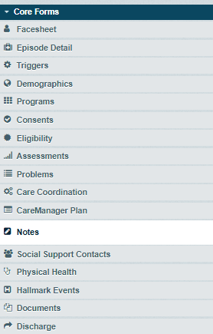

2. Click +New Note and then click New Client Search Note

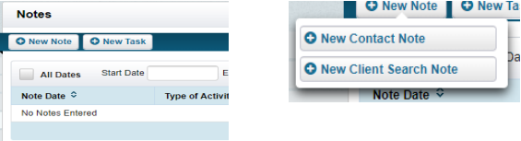

3. Complete the Client Search Note using the following fields:

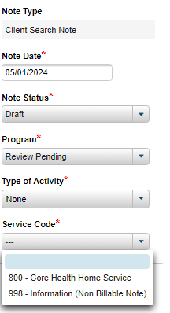

Note Detail
Note Type: Will automatically populate as Client Search Note to identify what note type you are in.
Note Date: The date you enter the note (will automatically default to current date when the note is finalized)
Note Status: Draft or Final. Finalized notes are used for billing purposes. Once the option of Final is saved the note is locked and it cannot be edited. Draft notes can be edited, but they will not support billing, and if you leave them in draft you cannot finalize any other notes or assessments.
Program: Will automatically populate.
Type of Activity: Use whichever code is applicable to the contact.
Service Code: For all Outreach activities, use code 998-Information (Not Billable Note)

Contact Detail
Client Search Date: Date of the service
Search Duration: Amount of time spent during the service, can be any amount of time.
Search Type: Identifies how the contact or service was provided.
Location: Identifies where the service was performed.
Contact Status: Whether or not you were successful in contacting the target of the service.
Consent: The consent area will become available when you select “Client Enrolled” in the Client Search Status bar. This is where you will document the Health Home consent in your enrollment note.

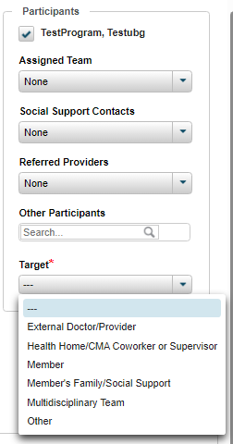

Participants
This section will provide drop downs for the Assigned Team, Social Support Contacts, Referred Providers, and Other Participants once they have members on their care team. These drop downs are optional as the specifics about who was involved in the service will be captured in the note details.

Target: This field captures who the target of the encounter was as shown above.

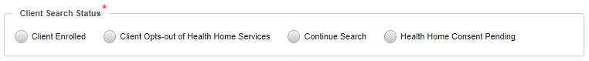

Client Search Status

Client Enrolled: Contact with the client has been established and the client has agreed to services.
Client Opts-out of Health Home Services: Contact with the client has been made and the client declines services from a Health Home.
Continue Search: The client has not yet been found and the search continues.
Health Home Consent Pending: Contact with the client has been established yet no consent for services has been received.

Continued Search – Client Search Status
If Continue Search is selected, the +New Consent button will remain disabled.
Enter information about the search activity in the Note field.
Once the form is completed, select the Save or Save & Close button.

Health Home Consent Pending – Client Search Status
If Health Home Consent Pending is selected, the +New Consent button and the Follow-up Appointment section will become enabled.
With the Follow-up Appointment section, you would be able to enter appointment information if you have it; the time for the appointment in the Appointment Date and Appointment Time fields and a location from the Appointment Location drop-down menu. Enter information about the search activity in the Note field.

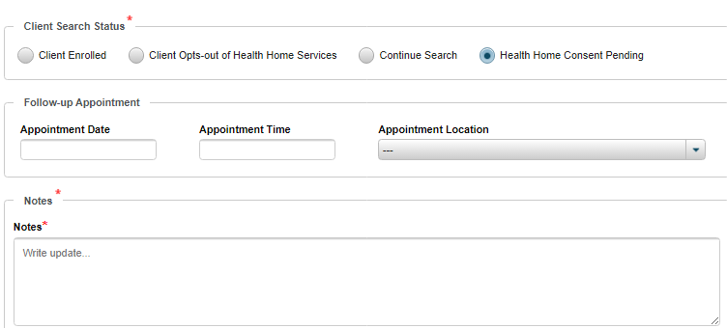

If consent for services has been received, select the New Consent button in the Contact Detail section and fill out the applicable fields.

Once the form is completed, select the Save or Save & Close button.

Outreach Note Example

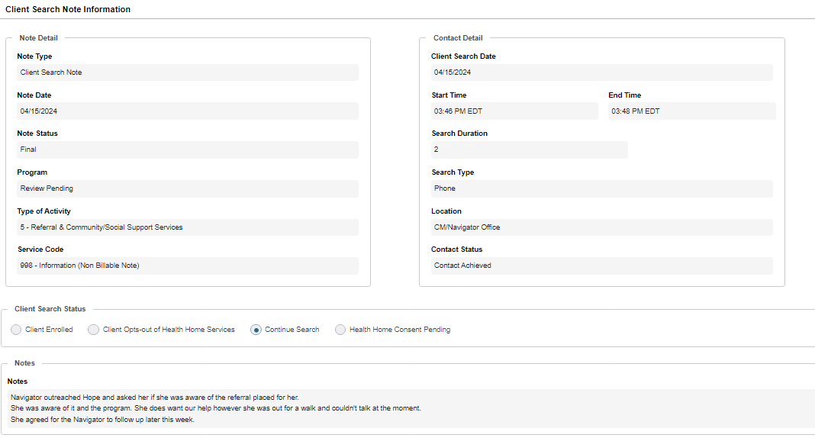

Enrollment Note: Client Search Note

Once the Eligibility Screen and the Problem(s) (Diagnosis Information) is/are updated in the Problem List, a Client Search Note must be completed to move the client into an Enrolled status.

1. Select Client Enrolled in the Client Search Status bar to move the client into an enrolled status.
2. Enter note details regarding verifying eligibility and confirming criteria was met for enrollment into a health home and who has consented to Health Home services for the client
3. Add the Health Home Consent (DOH 5055)
a. Click on the +New Consent in the Client Search Note
b. Update the Start Date to the date the client’s parent/guardian/legally authorized representative signed the consent (DOH 5055)
c. Click on the Client Opt-in/Out drop down and select Client Opt-in
d. Leave End Date and Expiration Date Blank
e. Enter any comments at the bottom of the consent and click the Add Comment button. If consent to enroll was provided by the member’s parent/guardian/legally authorized representative, include that information in the comments field
f. Click Save
4. Mark the Note Status in the Client Search Note as Final and click Save & Close

Contact Note

Billable Note
Billable Contact Notes
1. Select the Notes tab of the client’s chart you are entering a note.
2. Select +New Note and then click New Contact Note
3. Complete the following fields:

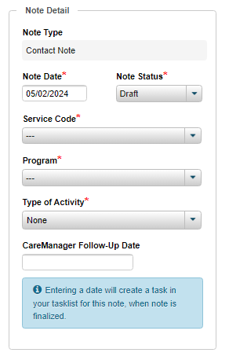

Note Detail
Note Type: This will prepopulate to contain the type of note you are completing
Note Date: auto-populates to the date the note is finalized in the system
Note Status: Draft or Final. Ensure all information in the note is correct before you change the status to final.
Service Code: Non Billable or Comprehensive Care Management
Type of Activity: Select the core service provided in the activity/encounter being documented. CareManager Follow-Up Date: Optional field for a Care Manager to enter a date for follow-up.
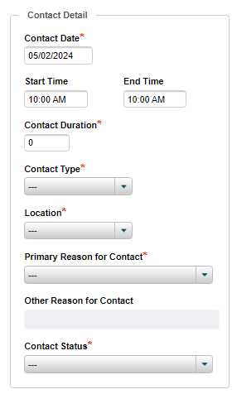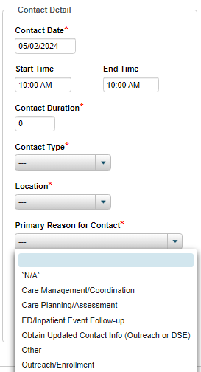

Contact Detail

Contact Date: The date that the service took place.
Contact Duration: Document the number of minutes the activity took you to perform
Contact Type: Select the way in which the contact was attempted or completed.
Location: The location where the Care Manager is at when the activity was performed
Primary Reason for Contact: Select the option that describes the activity/encounter being documented. Please see above for the complete drop down.
Contact Status: Contact Achieved or Unable to Contact

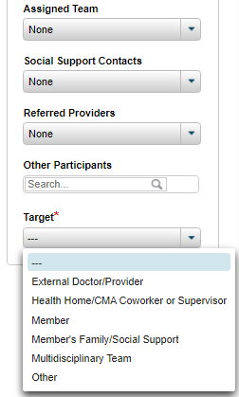

Participants
Box next to client’s name, Assigned Team, Social Support Contacts, Referred Providers, Other Participants will have a drop-down option once contacts and providers are entered. Your note detail section should include specifics about who was involved in the activity being documented as well. Target: Who the target of the activity was.

Notes
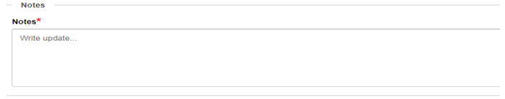

Notes: This section is where you write the narrative of the contact, expanding on the information in the drop downs, and ensuring it was a billable service.

Non-billable Note

Documenting a Non-Billable Contact Note
Follow the instructions detailed above to document Contact Notes that capture non-billable work. Non-billable Contact Notes are used for keeping track of services that are not part of the Care Plan, or that do not meet the standard for core services. These notes are also used for changes of status such as Dilligent Search Efforts of Excluded Settings.
Status Update

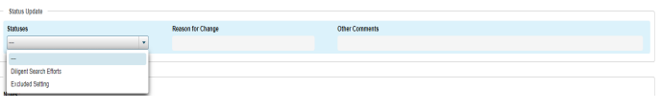

Statuses: This section is where you would move client’s to Diligent Search Efforts, or into an Excluded Setting. You will also need to provide a reason for the change, and any additional comments that will clarify why there was a status change. To move them back into an Enrolled status you will need to enter another Contact Note and select the Status of Enrolled.

If you do not move the status back to Enrolled by the time allotted by the DOH (3 months for Diligent Search, 6 months for Excluded Setting) your client will automatically by Discharged.

CareManager Note

Billable Note
CareManager Notes for a client already in CareManager can be accessed from the Dashboard.
- From the Dashboard, select a client from the Client List.
- Once in the client chart, select the Notes feature in the navigation list on the left.
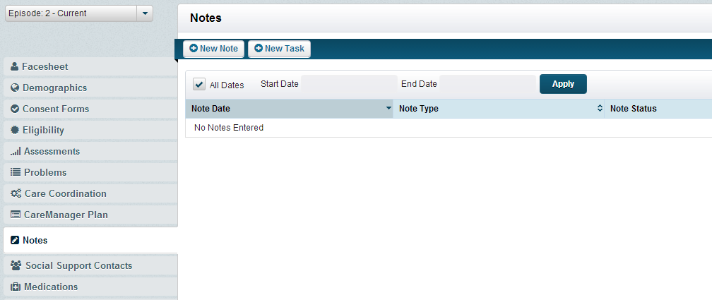
Note: CareManager Notes can also be found by selecting Client then Notes from the CareManager toolbar.

Adding a CareManager Note
Any prior notes that have been entered will be displayed in the Notes list.
- From the Notes page, select the button in the top-left corner of the Notes page.
- Select from the drop-down.
- The CareManager Note will display.
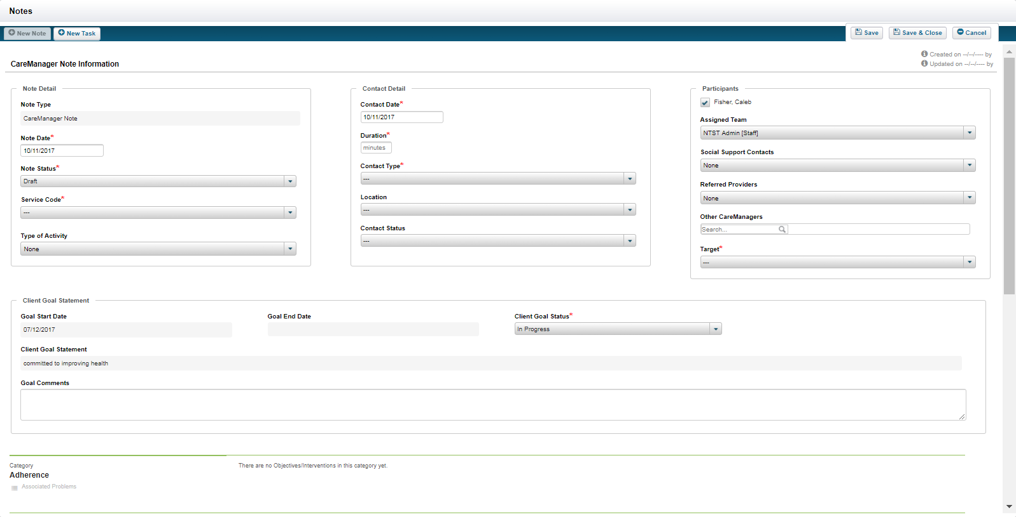
- The Note Type will auto-populate.
- The Note Date will default to the current date. Modify the date if needed.
- Select a Note Status drop-down. If Final is selected when the note is saved a user will be unable to modify the note. If Draft is selected, a user will be able to edit the saved note.
- Select the Service Code from the drop-down.
- The Contact Date will default to the current date. Modify the date if needed.
- Select the Contact Type from the drop-down.
- Enter the Contact Duration in minutes.
- Select the Location from the drop-down.
- The check box next to the participant’s name will automatically be checked.
- Select the appropriate Assigned Team, Social Support Contacts, and Referred Providers from the drop-downs.
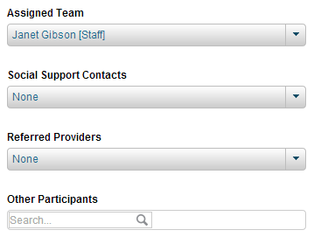
- Enter Goal Comments into the goal comments open text field if needed.
- Review the Intervention and modify if needed.
- Review the Status and modify if needed.
- Review the Target and modify if needed.
- Adjust the slider according to the client’s level of engagement between Not Engaged and Very Engaged for the “How engaged has the client been with this task?” Question.
- Enter detailed information in the Intervention Updates section.
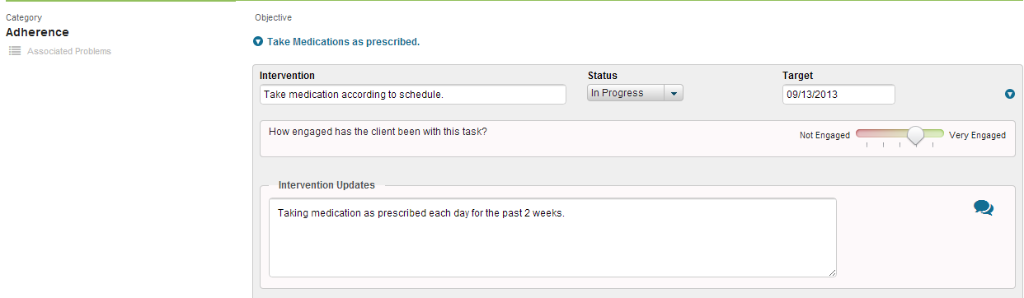
- Repeat steps 15 - 20 for any of the applicable remaining Interventions that you covered with the client during the visit. The CareManager note is designed to allow a Care Manager or Care Coordinator to only document the applicable interventions covered during the visit.
- If the note is ready to be finalized, select Final in the Note Status drop-down.
- Once the CareManager Note information has been entered, select the Save or Save & Close button.
Editing CareManager Note Information
CareManager Notes in a status of Draft can be viewed and modified if needed.
- From the Notes page, select the button next to the CareManager Note that needs modified.
- The previously entered information will display. To edit the information, select the button from the top-right corner.
- The fields that can be modified will become enabled in the CareManager Note feature.
- Once the CareManager Note information has been updated, select the Save or Save & Close button.

Non-Billable Note

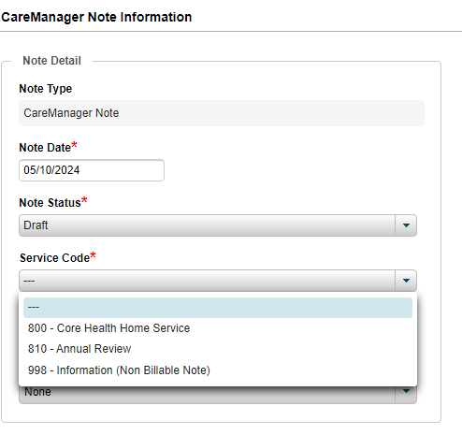

Hallmark Events
The Hallmark Events are important events that impact a client’s care either in a negative or positive way. These events can be entered, viewed and updated from the Hallmark Events page.
- From the Home Screen, select a client from the Client List.

- Select the Hallmark Events tab from the left.
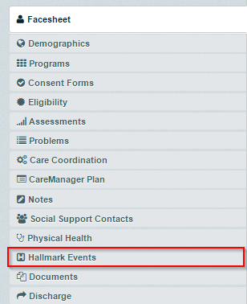

Adding a New Hallmark Event
- Select the button. The Hallmark Events page will display.
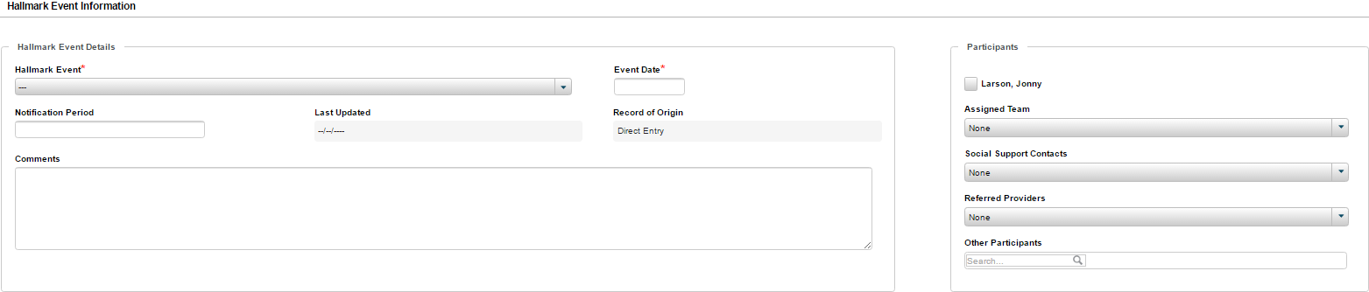
- Select from the Hallmark Event drop-down. Certain sections will enable additional fields at the bottom of the form if applicable.
- Select or enter the date in the Event Date field.
- Enter the Notification Period in the open text field.
- The Record Origin field will auto-populate.
- Enter pertinent information about the Hallmark Event in the Comments field.
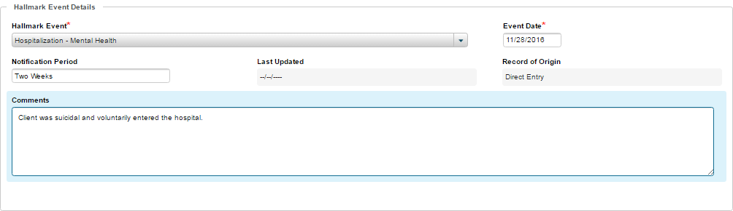
- In the Participants section, select the client checkbox, any Assigned Team, Social Support Contacts, and Referred Providers if applicable. If needed, search for Other Participants in the search field.
- If applicable, enter the information for the Hospitalization/Inpatient Details section including the Hospital or Facility, Primary Care Physician, Record Origin, Admission Date, Admission Time, Admission Reason, Discharge Date (if applicable), Discharge Time, Attending Physicican(s), and Consulting Physicians.
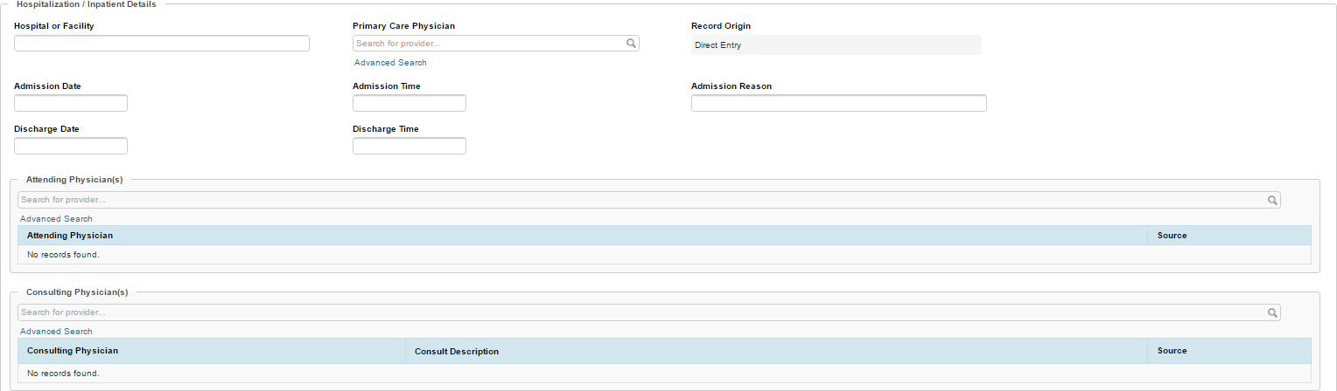
- Enter a diagnosis in the Admission Diagnosis field. Information will dynamically display based on the search criteria entered.
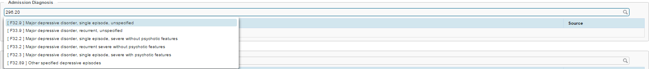
- If more than on diagnosis is needed, repeat step 9.
- Select the Primary Diagnosis by selecting the box under the Primary column.
- Enter information in the History of Present Illness field.
- Once the Hallmark Event information has been updated, select the or button.

Viewing and Editing Hallmark Event Information
Previously entered Hallmark Events can be viewed or edited if needed.
- From the Hallmark Events page, select the button next to the previous entry.
- The previously entered information will display disabled.
- To edit the information, select the button from the top-right corner of the page. An example of updating a Hallmark Event would be if a client was discharged from the hospital, you would be able to Edit the event and update the discharge date.
- The fields that can be modified will become enabled.
- Once the Hallmark Event information has been updated, select the or button.

ED Alert Documentation

When selecting ED Visit in the Hallmark Event Drop Down be sure to complete all areas of the Hallmark Event as thoroughly as possible including but not limited to discharge condition comments with the persons follow up appointment information. Be sure to include information about any physician follow up as well.

Attachments

The Attachment feature allows the user to upload and download uploaded documents from his/her computer from the client chart. You may also delete documents that no longer pertain to the client.

Attachments Overview
The Attachment page allows for the following actions:
- Attach
- View
- Delete
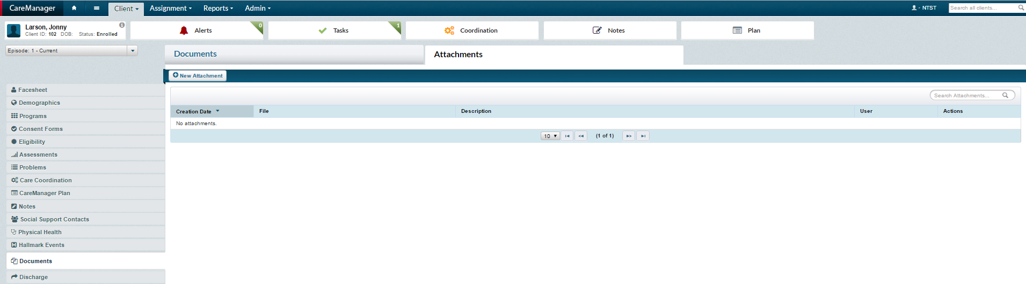
Note: Fields with a red asterisk * indicate required fields. While other fields are not required, the more information entered about the client the better.

Navigating to Attachments
Attachments is opened through the Documents feature which can be accessed from the Home Screen.
- From the Dashboard, select a client from the Client List.

- Select the Documents tab from the left side of the page.
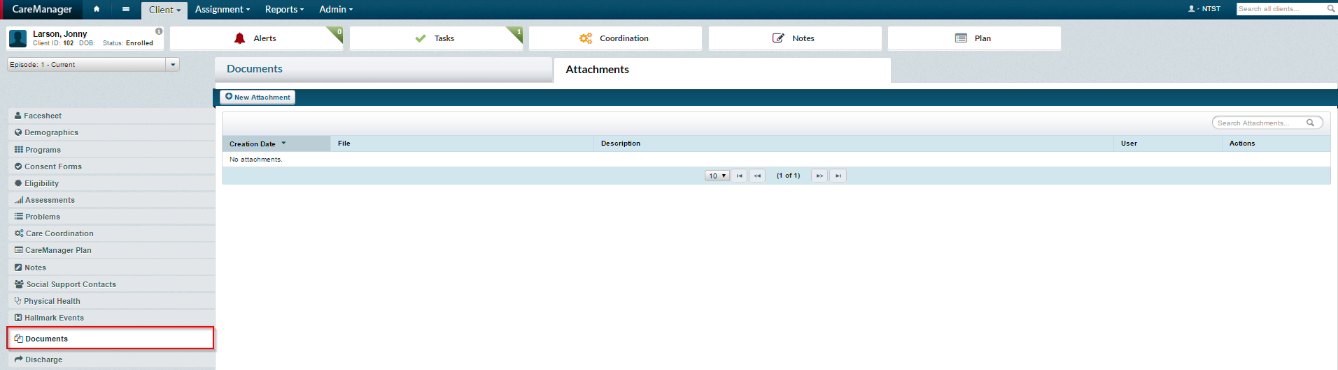
- Select the Attachments tab from the top of the Documents feature to display the Attachments page.
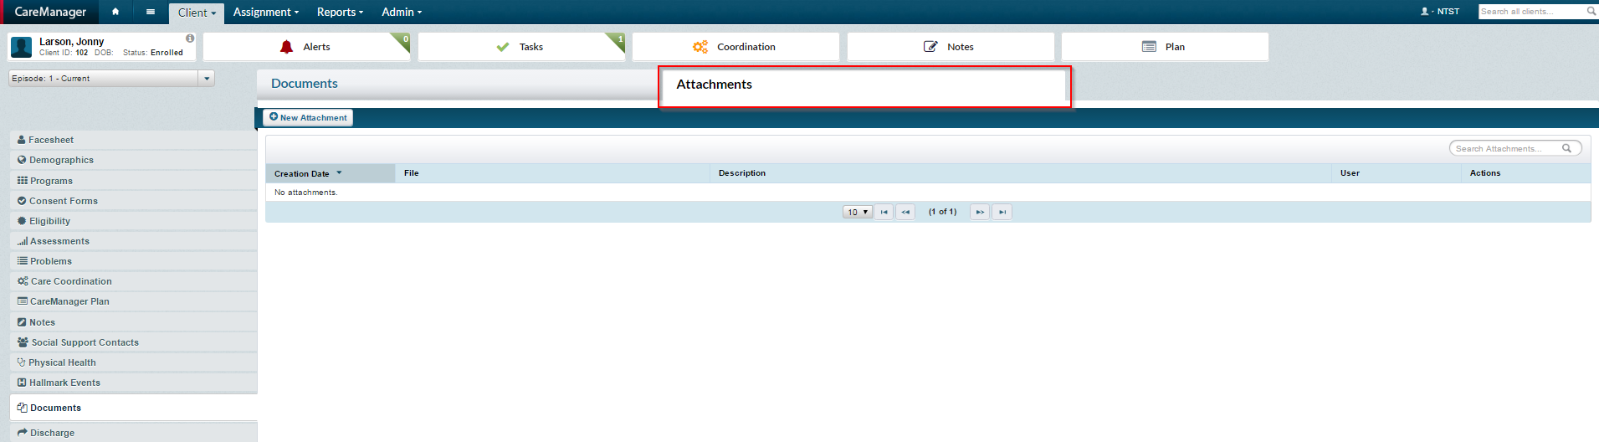
- Select the button, to add a new attachment to your client’s chart.
- The New Attachment modal will present.
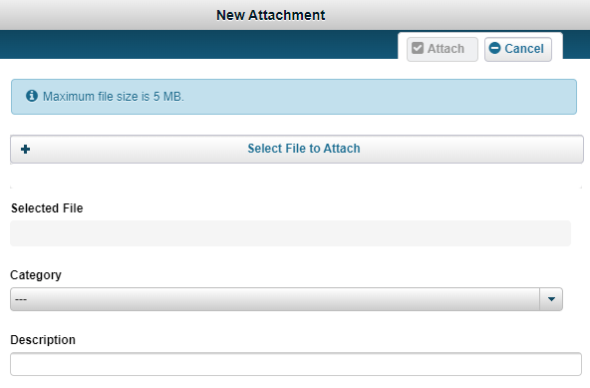

- Select the button to add the file you wish to attach.
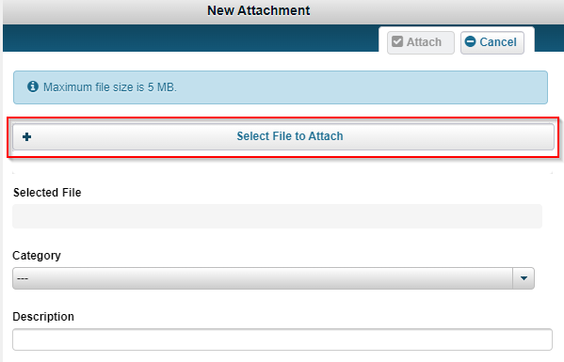

- This will prompt you to search for the document you wish to add. Select the file to be attached to the client’s chart and click the button or double click the document. You will now see the document you selected in the Selected File field.
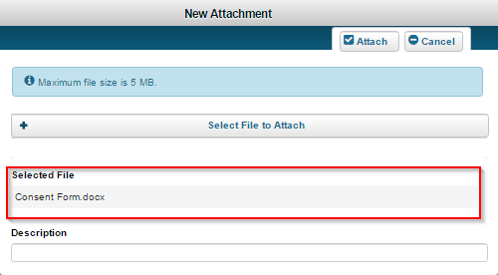
- Identify the attachment by writing in the Description open text field. Be sure to use naming convention
Date_Form Name_Member Initials
For Example 05.01.24_DOH-5055_JL

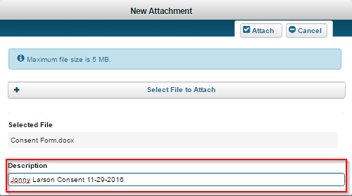
- Select the Attach button to finish attaching the document to the client’s chart.
- The green banner stating “Attachment ‘DocumentName.FileType’ added” The attached file will present as a row item in the Attachment feature.
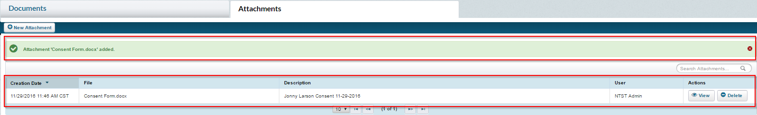

Viewing Attachments
Attachments can be viewed easily from the Attachments page.
- From the Attachments page, select the button from the Actions column.
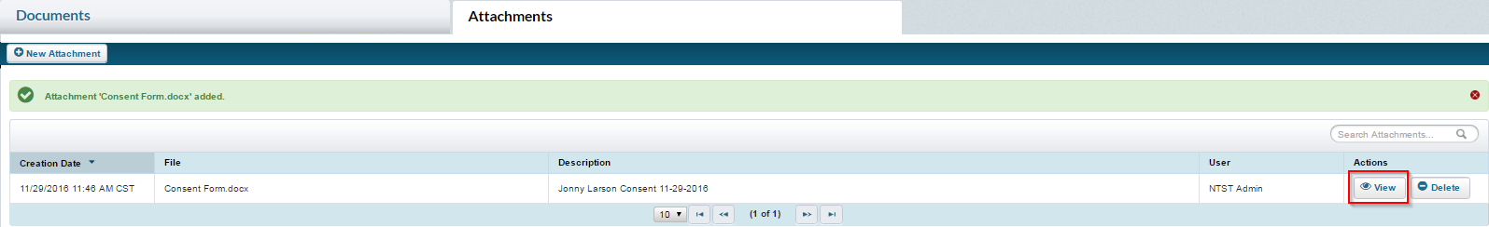
- The Save As box will appear. Choose where you would like to save the file and select the windows button. Once save has been selected, the file can be opened by double clicking the file at the bottom of the screen.
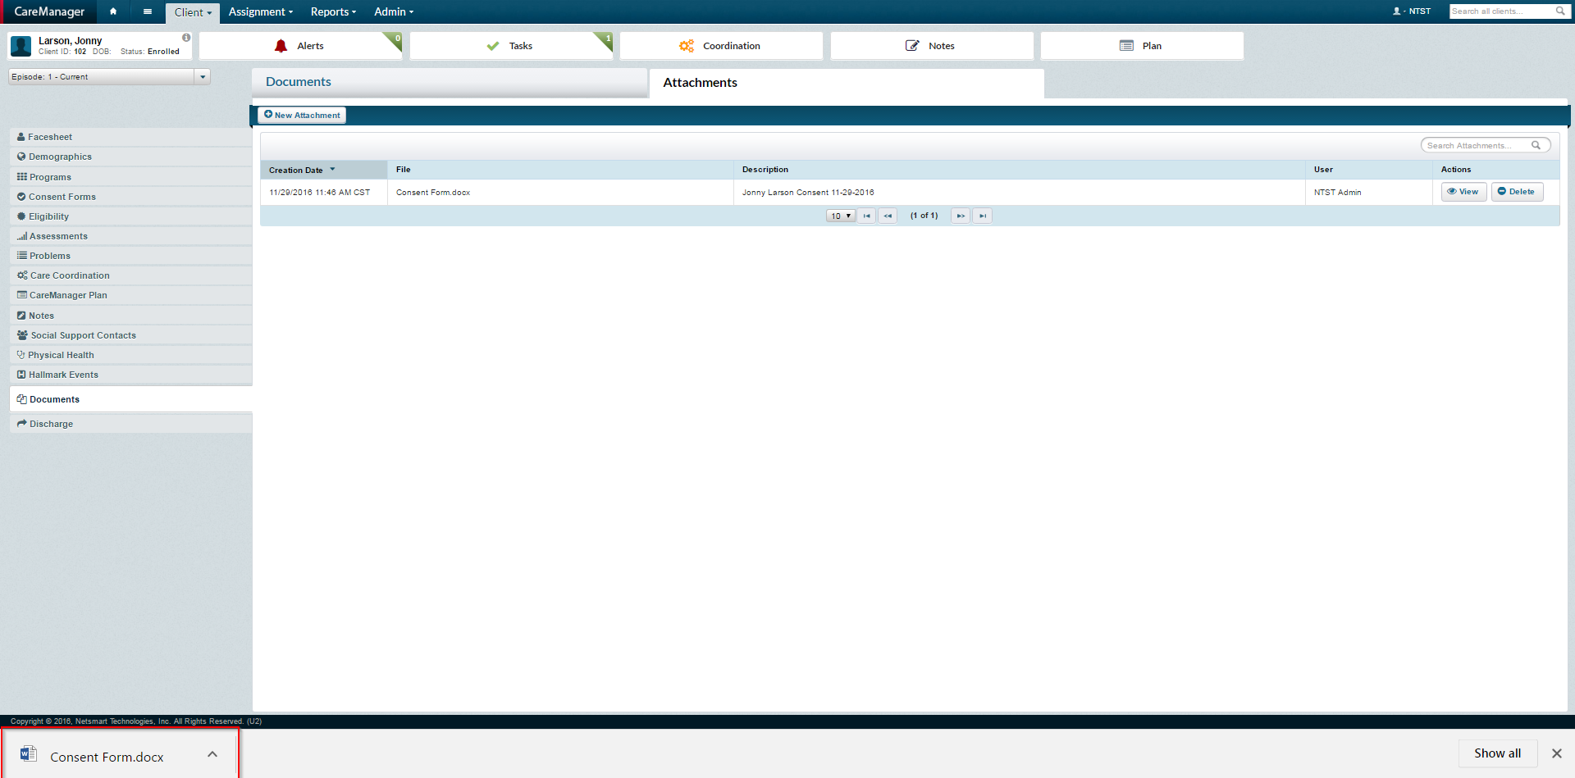
Deleting Attachments
Attachments can be deleted easily from the Attachments page.
- From the Attachments page, select the button from the Actions column.
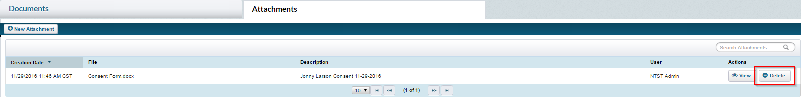
- The Confirm modal will appear asking if you are sure you want to delete the attachment.
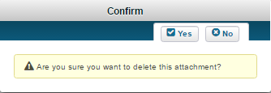
- To confirm, select the button.
- The window will close and the attachment will no longer present as a row item within the Attachment page.
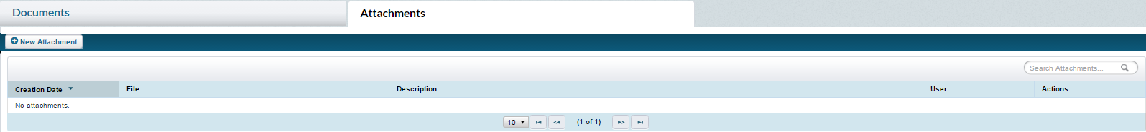

Member Discharge

The Discharge feature can be found within the client chart. This feature contains information related to the discharge of a client. In CareManager when a client is discharged it will end the client’s current episode.

Discharge Overview
The Discharge feature is comprised of only one section and allows the user to select various reasons for a Discharge including:
- Deceased
- Disenrollment from State HH Program
- Health Home Services No Longer Needed
- Incarcerated
- Lost Health Home Eligibility
- Moved From County of Service
- Moved Out of State
- Other
- Rescinded Consent for Health Home
- Treatment Discontinued at Beneficiary’s Request

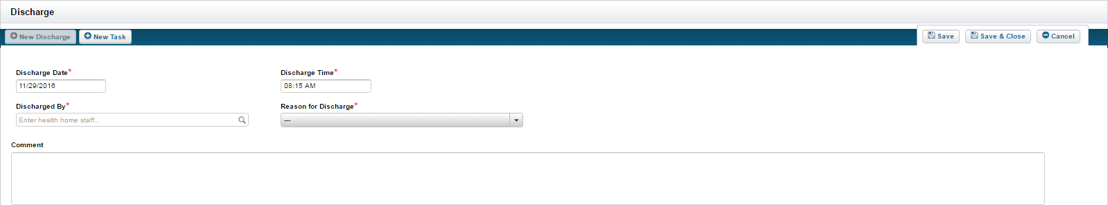
Note: Fields with a red asterisk * indicate required fields to complete a Discharge.

Navigating to Discharge
To discharge clients in the system navigate to the client chart.
- From the Dashboard, select a client from the Client List.
- Select the Discharge feature from the navigation list on the left.
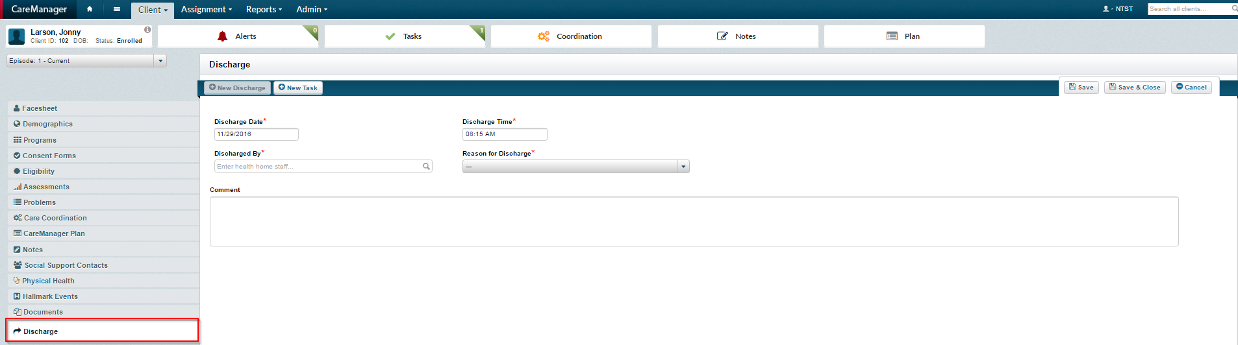
Note: Discharge can also be found by selecting the Client Menu and clicking on the Discharge Client link.
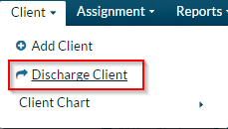

Discharging a Client
Any prior discharges that have been recorded will be displayed in the Discharge list.
- If Discharge information has previously been entered, select the View button. In this example, no previous discharges have been recorded.
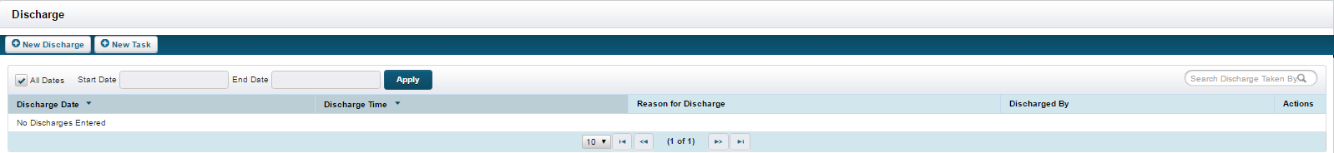
- Select the +New Discharge button to discharge the client.
- The Discharge Date will default to the current date. Modify if needed.
- The Discharge Time will default to the current time. Modify if needed.
- Search in the open field Discharge By for the correct staff member. As you type the staff member’s name, a selection will drop down with people who start with the letters you are typing from the system.
- Select the Reason for Discharge from the drop-down menu.
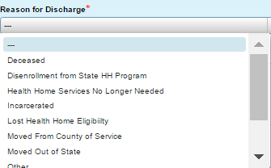
Note: Depending on which reason you select, other fields may display.

Discharge for Deceased Only
If Deceased is selected for the Reason for Discharge, a new section titled Deceased Details will appear.
- Enter the correct date in the Date of Death field. Select the Reason for Death from the drop-down menu.
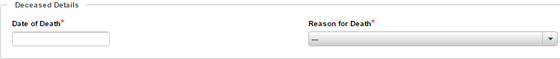
Transferred to Another Health Home Only
If Transferred to Another Health Home is selected for the Reason for Discharge, a new section titled Transferred to another Health Home Details will appear.
- Select the correct New Health Home from the drop-down menu.
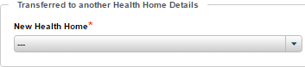
Moved From County of Service Only
If Moved from County of Service is selected for the Reason for Discharge, a new section titled Moved from county of Service Details will appear.
- Select the correct New County of Service from the drop-down menu. Enter the correct Forwarding Address from the open text field.
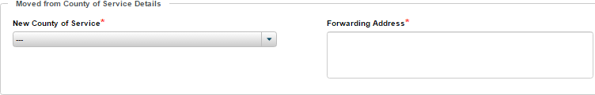
Moved Out of State Only
If Moved Out of State is selected for the Reason for Discharge, a new section titled Moved out of State Details will appear.
- Enter the correct address in the Forwarding Address open field.
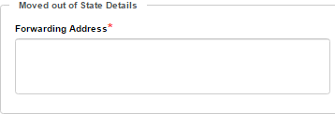
Other
If Other is selected for the Reason for Discharge, a new section titled Other Details will appear.
- Enter the reason in the Other Reason field.
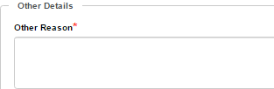
All Other Selections
All other selections not specifically described above will have Comment as the remaining field available.
- Enter any comment in the Comment open text field.
- Once the Discharge information has been entered, select the Save or Save & Close button.

Additional Forms

AHC HRSN SDOH Screening
- To document the Annual SDOH Screening select AHC HRSN SDOH Screening.

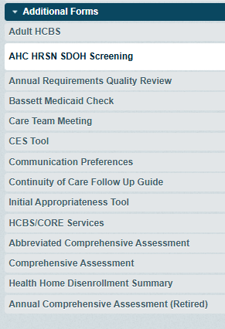

- Click New AHC HRSN SDOH Screening
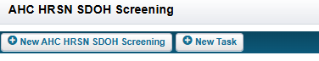
- Complete all sections of the form based on information from the member.
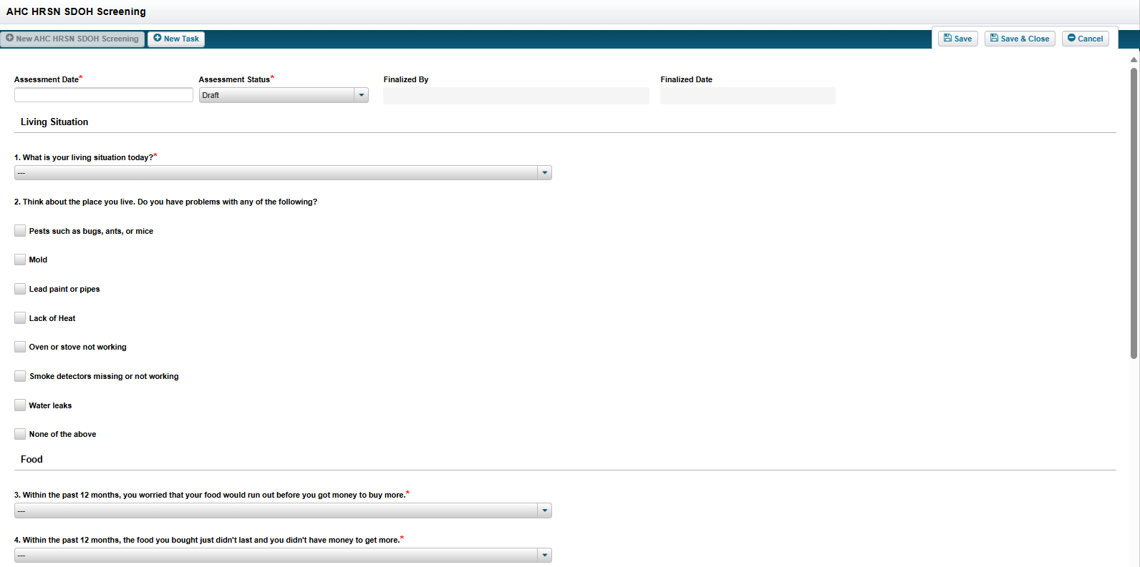
- Once all sections are complete finalize the AHC HRSN SDOH Screening Save and Close.

Bassett Medicaid Check
- To document monthly Medicaid check select Bassett Medicaid Check.
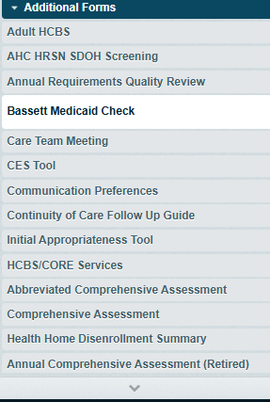

- Select the drop down Per ePACES- Member Medicaid Eligible
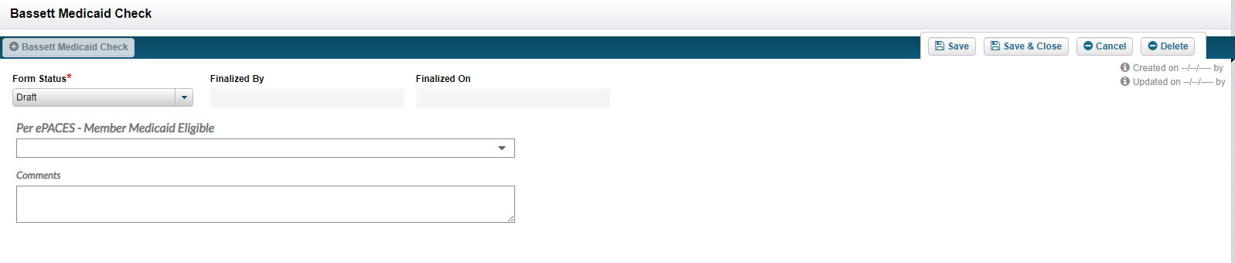

- Select Yes or No, Comments field can be used to indicate H codes.
- Change Form status to Final then Save and Close

Care Team Meeting
- To complete a Care team Meeting Form select Care Team Meeting
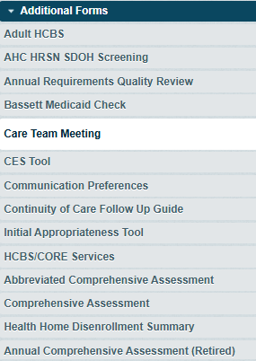

- Complete all sections of the form including comments fields.
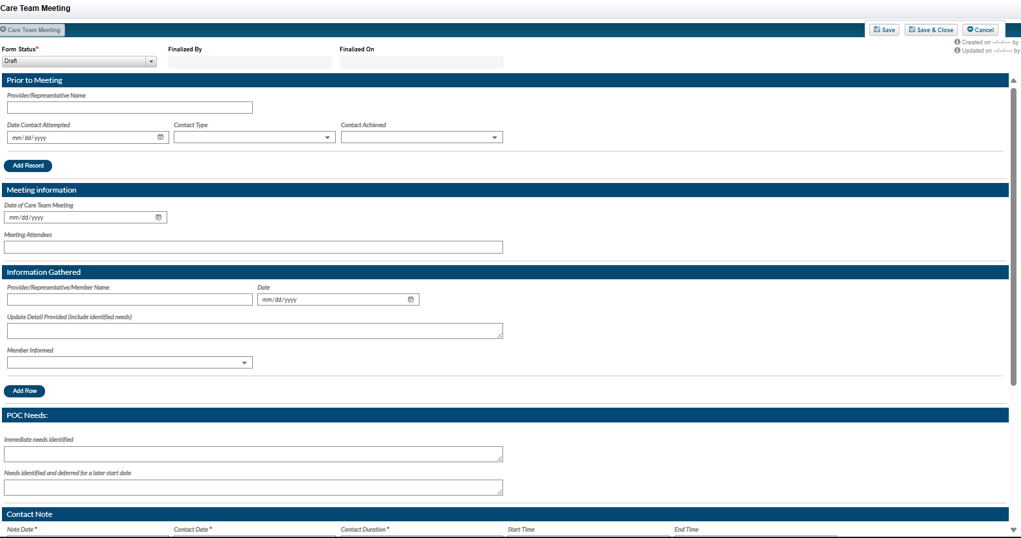

- Complete the Contact Notes section of the form as well.
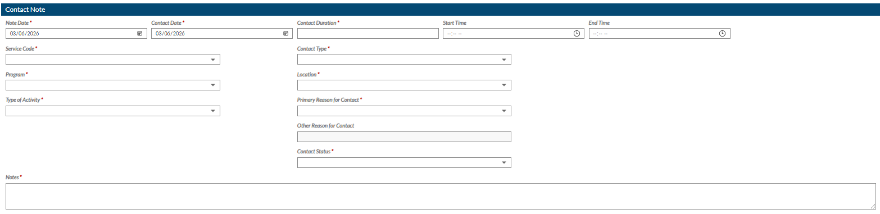

- You will now be able to view your note in the notes section as well as in the form section of NetSmart.
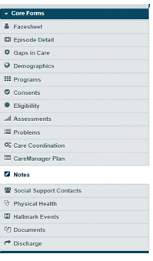

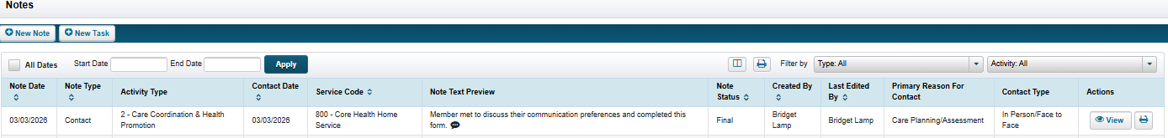

- When completing an HML the 800 contact note completed with forms can now be used as a billable service

CES Tool

- To complete the CES Tool click CES Tool.
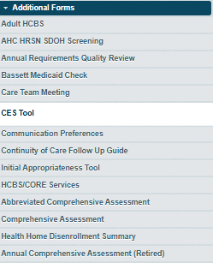
- Complete all sections of the form including comments fields.
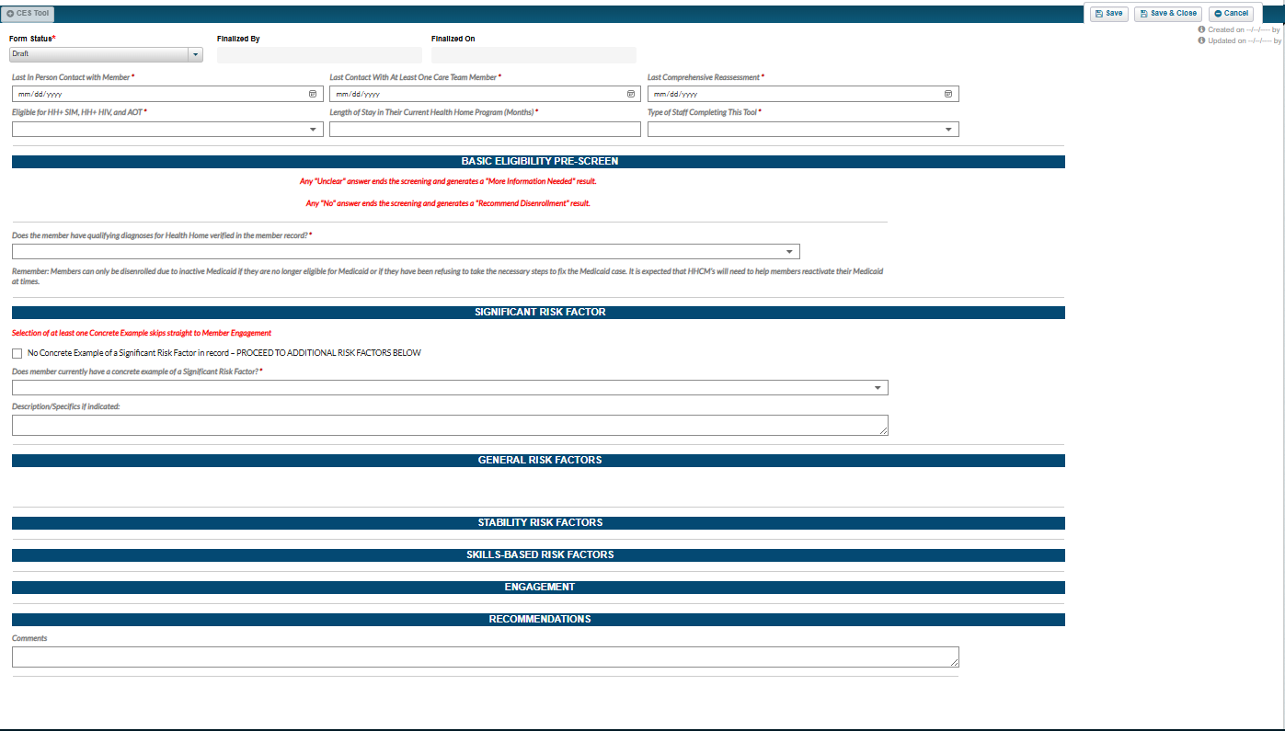

- This form must be finalized by a Quality or Supervisor per DOH policy.

Communication Preferences
- To complete the Communication Preferences Form click on Communication Preferences.

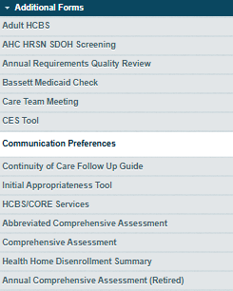
- Then Click + Communication Preferences.

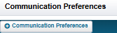
- Complete the form being sure to complete the contact note section at the bottom of the form. Before finalizing be sure that all fields with a red asterix are filled in.

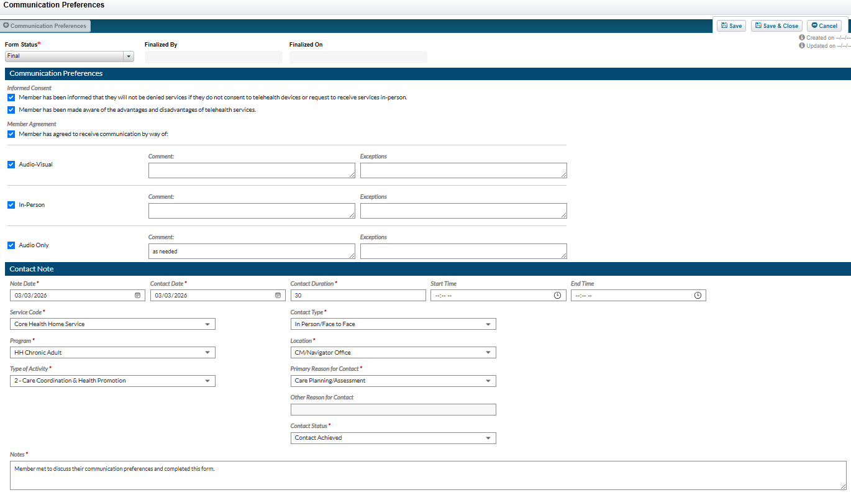
- Save and Close
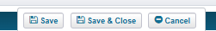
- You will now be able to view your note in the notes section as well as in the form section of NetSmart.

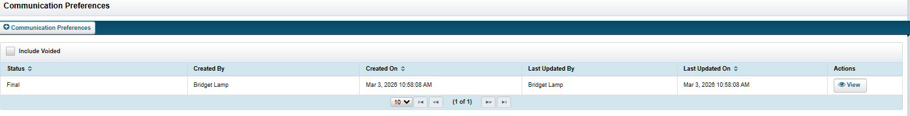

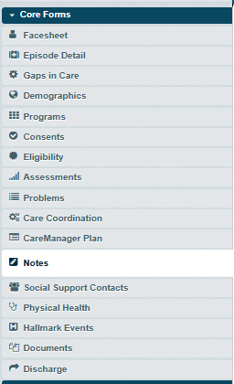

- When completing an HML the 800 contact note completed with forms can now be used as a billable service

Continuity of Care Follow up Guide

- To complete the Continuity of Care Follow Up Guide click on Continuity of Care Follow Up Guide.
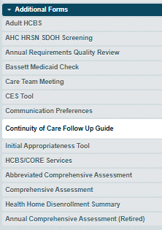

- Then Click + Continuity of Care Follow Up Guide.

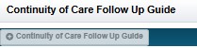

- Complete the form being sure to complete the contact note section at the bottom of the form. Before finalizing be sure that all fields with a red asterix are filled in.
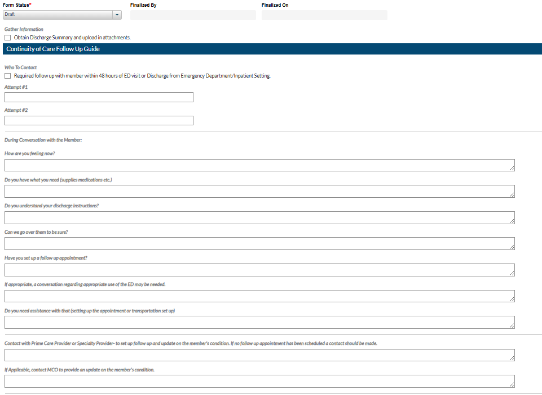
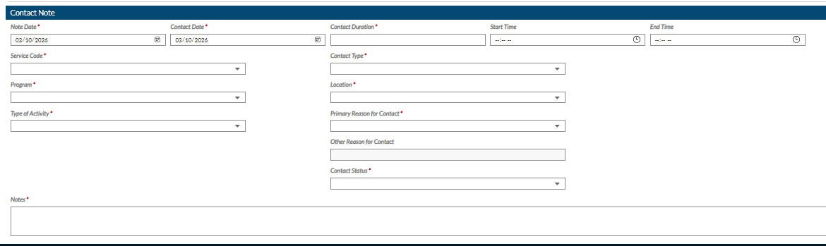

- Save and Close
- You will now be able to view your note in the notes section as well as in the form section of NetSmart.

- When completing an HML the 800 contact note completed with forms can now be used as a billable service

Initial Appropriateness Tool

1.To complete the Initial Appropriateness Tool click on Initial Appropriateness Tool.
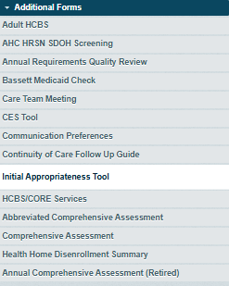
2.Then Click + Initial Appropriateness.
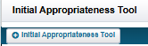

- Complete the form being sure to complete the contact note section at the bottom of the form. Before finalizing be sure that all fields with a red asterix are filled in.
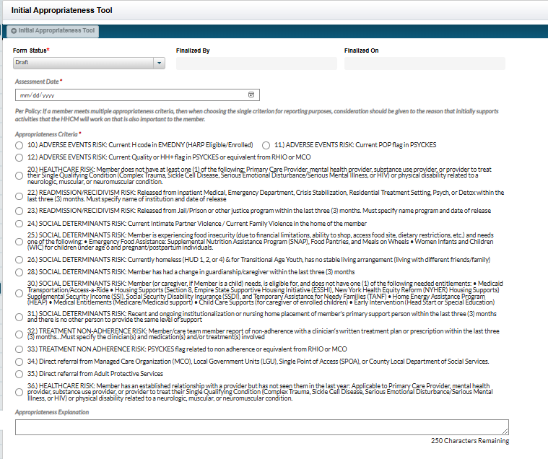
- Finalize Save and Close
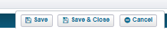

HCBS/CORE Services

- To complete the HCBS/CORE Services Form Click HCBS/CORE Services.
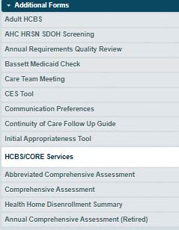
3.. Click + HCBS/CORE Services
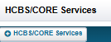

4.Complete all required fields and add additional providers as needed. Complete the notes fields as well.
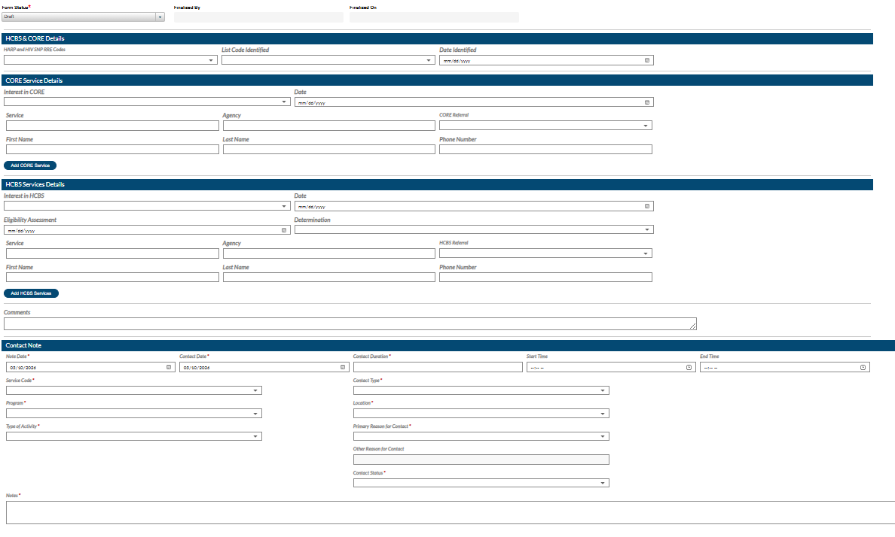
5.Save and Close
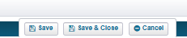

6.You will now be able to view your note in the notes section as well as in the form section of NetSmart.

7. When completing an HML the 800 contact note completed with forms can now be used as a billable service

Abbreviated Comprehensive Assessment

1.To complete the Abbreviated Comprehensive Assessment, click Abbreviated Comprehensive Assessment.
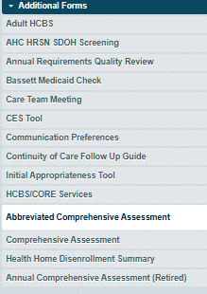

2.To Add a new Abbreviated Comprehensive Assessment click + Abbreviated Comprehensive Assessment.

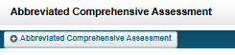
3.Complete all sections of the form and provide a description of the changes needed to the original comprehensive assessment. Document in Hallmark Events as well and adjust the Plan of Care accordingly.

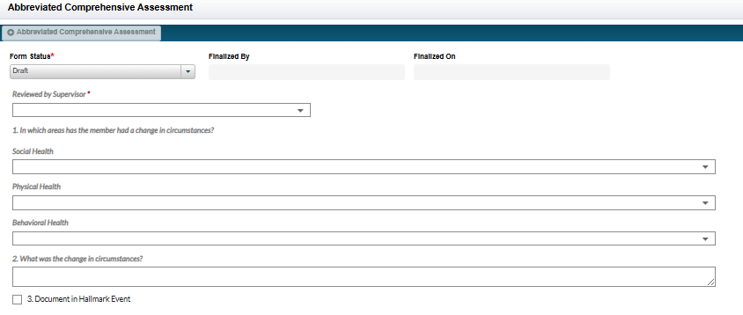
4.Finalize Save and Close.
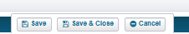

Comprehensive Assessment

1.Click Comprehensive Assessment
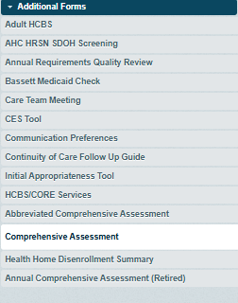

2.Click + Comprehensive Assessment
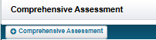

3.Complete All Required Areas being sure to complete all tabs. Every section will be several questions to answer in order to progress through the Comprehensive Assessment. Section 9(MMS) is only required for individuals with a mental health diagnosis that are not currently engaged with a mental health provider for the past 6 months. Section 11 CAGE-AID is only required for individuals with active substance use disorders. You can save and come back to this assessment if needed be sure to Save.
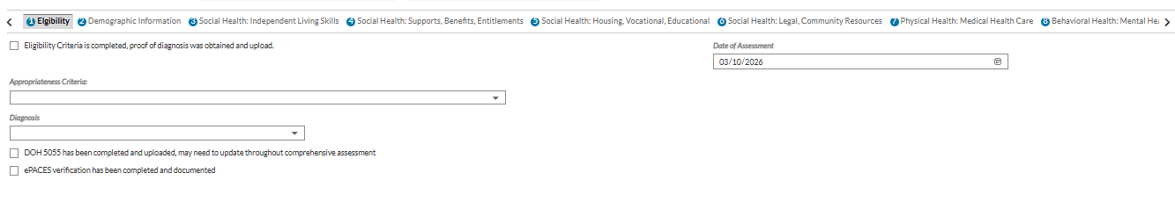
4.Finalize Save and Close
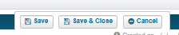

Health Home Disenrollment Summary
- Click on Health Home Disenrollment Summary
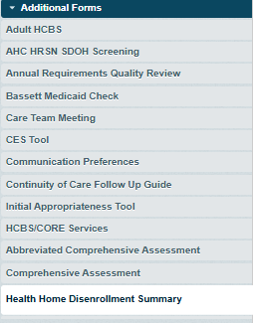

- Click + Health Home Disenrollment Summary
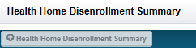

- Complete all sections including the contact note at the bottom of the form.
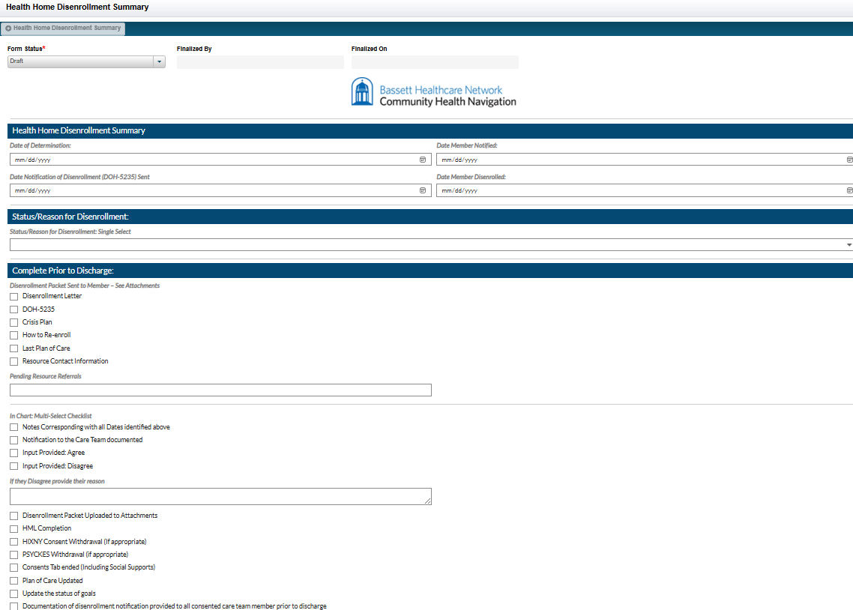
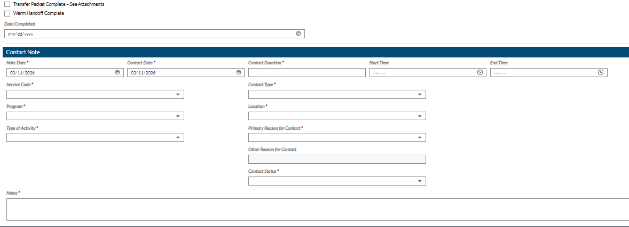

- Finalize Save and Close

- You will now be able to view your note in the notes section as well as in the form section of NetSmart.

- When completing an HML the 800 contact note completed with forms can now be used as a billable service

